**\*\*\* FORM DUE BY THE 5TH DAY OF EACH MONTH; PAYMENT MAY BE DELAYED WHEN THIS FORM IS INCOMPLETE. \*\*\***

**CUSTOMER INSTRUCTIONS:**

Date Stamp:

**Employment:** Attach paycheck stubs received for the month. Paycheck stubs covering all the days of the month is needed to show the number of hours you worked the entire month. Report actual daily hours worked. Do not include lunch hours. Use a separate line for each employer. **Supervisor signature is not required.**

If self-employed, please provide proof of income received during the month and hours worked.

**Other Activities:** All other approved activities and hours must be verified by the counselor or supervisor of the activity. Use a separate line for each class/activity.

**Vocational Education:** **Do not** enter your study time hours your case manager will enter them.

Please convert your minutes to decimals using the chart below

**Daily and Activity Totals:** **Do not** enter the daily or activity totals your case manager will complete that section.

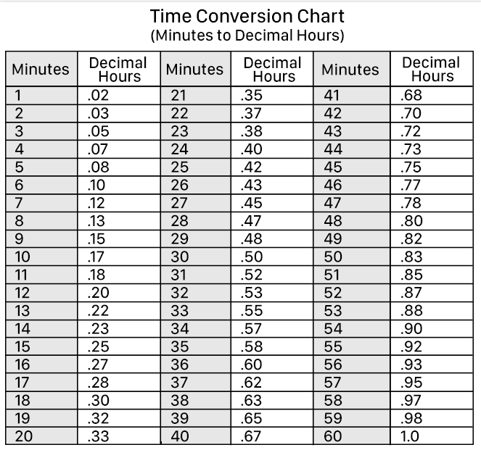

Further, you understand that email messages are not confidential. Communication service providers used by me or the County as well as anyone with access to my email and/or phone may be able to see these notifications.

|  |  |  |  |  |  |  |  |  |  |  |  |  |  |  |  |  |  |  |  |  |  |  |  |  |  |  |  |  |  |  |  |  |  |  |  |
| --- | --- | --- | --- | --- | --- | --- | --- | --- | --- | --- | --- | --- | --- | --- | --- | --- | --- | --- | --- | --- | --- | --- | --- | --- | --- | --- | --- | --- | --- | --- | --- | --- | --- | --- | --- |
| **CUSTOMER NAME:** | | | | | | | | | | | **CASE NUMBER:** | | | | | | | | | **REQUIRED MONTHLY HOURS:** | | | | | | | | | | **Month & Year:** | | | | | |
| **Enter the NUMBER of hours you attended, worked, or studied. Do this EVERY DAY for EACH CLASS / ACTIVITY / JOB.** | | | | | | | | | | | | | | | | | | | | | | | | | | | | | | | | | | | **County Use** |
| Class/Activity/ Job or Study Time | **1** | **2** | **3** | **4** | **5** | **6** | **7** | **8** | **9** | **10** | | **11** | **12** | **13** | **14** | **15** | **16** | **17** | **18** | | **19** | **20** | **21** | **22** | **23** | **24** | **25** | **26** | **27** | | **28** | **29** | **30** | **31** | **Activity**  **Totals** |
| A. |  |  |  |  |  |  |  |  |  |  | |  |  |  |  |  |  |  |  | |  |  |  |  |  |  |  |  |  | |  |  |  |  |  |
| B. |  |  |  |  |  |  |  |  |  |  | |  |  |  |  |  |  |  |  | |  |  |  |  |  |  |  |  |  | |  |  |  |  |  |
| C. |  |  |  |  |  |  |  |  |  |  | |  |  |  |  |  |  |  |  | |  |  |  |  |  |  |  |  |  | |  |  |  |  |  |
| D. |  |  |  |  |  |  |  |  |  |  | |  |  |  |  |  |  |  |  | |  |  |  |  |  |  |  |  |  | |  |  |  |  |  |
| E. |  |  |  |  |  |  |  |  |  |  | |  |  |  |  |  |  |  |  | |  |  |  |  |  |  |  |  |  | |  |  |  |  |  |
| F. |  |  |  |  |  |  |  |  |  |  | |  |  |  |  |  |  |  |  | |  |  |  |  |  |  |  |  |  | |  |  |  |  |  |
| G. |  |  |  |  |  |  |  |  |  |  | |  |  |  |  |  |  |  |  | |  |  |  |  |  |  |  |  |  | |  |  |  |  |  |
| Daily Totals |  |  |  |  |  |  |  |  |  |  | |  |  |  |  |  |  |  |  | |  |  |  |  |  |  |  |  |  | |  |  |  |  |  |

## COUNSELOR/CW OFFICE: Please sign, enter your phone number and indicate the individual’s progress. Your signature certifies verification of the hours listed above.

A. CLASS / ACTIVITY: Attendance verified by: ____________________________________ (Counselor Signature) **Phone:** ______________

## Comments:

B. CLASS / ACTIVITY: Attendance verified by: _____________________________________ (Counselor Signature) **Phone:** ______________

## Comments:

C. CLASS / ACTIVITY: Attendance verified by: _____________________________________ (Counselor Signature) **Phone:** ______________

## Comments:

**Customer Release / Certification:** I understand that all activities reported above, including employment, may be verified and my signature gives consent to CalWORKs Welfare to Work to do so if needed. The above days and hours of attendance are used to figure any transportation and / or childcare payments owed to me. I declare under penalty of perjury under the laws of the United States and the State of California that this report is true and correct and complete for the entire report month.

County Use Only: Total Monthly Hours: ______

Verified by: _________________________________

Date: ____________________

|  |
| --- |
| Customer Signature |
| Phone Number [if new, please check box ] |
| Date |