# Adding Kurzweil 3000 Read the Web as an Extension on Firefox

*1. Open Firefox (Version 50 or greater).*

*2. Open Kurzweiledu.com download page:* [*https://www.kurzweiledu.com/news-resources/software-updates/misc-updates_v16.html*](https://www.kurzweiledu.com/news-resources/software-updates/misc-updates_v16.html) *The* ***Other Tools for Version 16*** *page opens.*

*3. Download the file below, open Firefox on the machine where Read the Web will be used, and then drag and drop the file onto Firefox. The latest Read the Web (RTW) version can be found on the website: (*<https://www.kurzweiledu.com/downloads/currentversion/firefox-addons/readtheweb_3_2_18.xpi>*)*

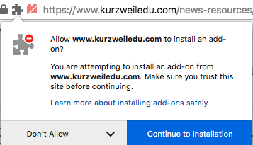

*4. Note: You may get a warning about Firefox blocking installation. Click* ***Continue to Installation****. A message appears about installing an add-on.*

*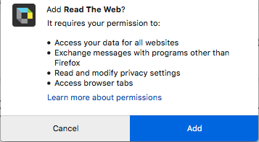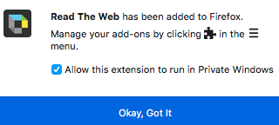5. Click* ***Add****. You will get a message that it has been installed successfully.*

*6. Close the message. Open a web page   
(e.g.,* [*https://www.kurzweiledu.com*](https://www.kurzweiledu.com)*)*

*You should see the Read the Web icon in the upper right of your Firefox browser.*



7. Log into the Kurzweil 3000 Read the Web toolbar.



8. Your Read the Web Toolbar is opened and ready to use.

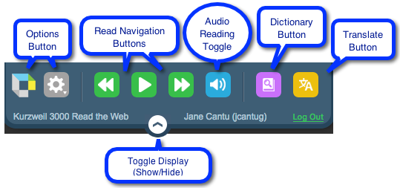 **Note**: See the identified parts of the Read the Web toolbar below.