# Adding Kurzweil 3000 Read the Web as an Extension on Chrome

*1. Be sure you have the Chrome browser installed.*

*2. Locate the Google Search field on the Chrome browser and search for the Chrome Web Store.*

*3. Click the Chrome Web Store link. The Web Store is displayed.*

*4. Click Extensions. In the Search box type* ***Kurzweil 3000****. The results window displays Kurzweil 3000 Read the Web.*

***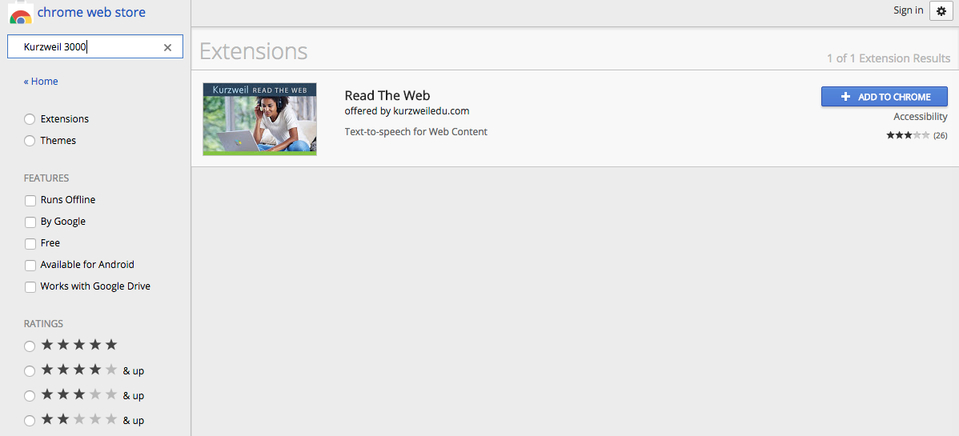****5. Click the blue* ***+ADD TO CHROME*** *button. A confirmation window is displayed.*

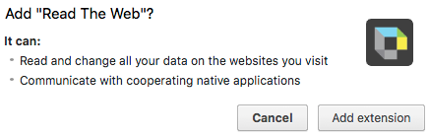

*6. Click the* ***Add extension*** *button. An instruction window is displayed.*



7. Log into the Kurzweil 3000 Read the Web toolbar.

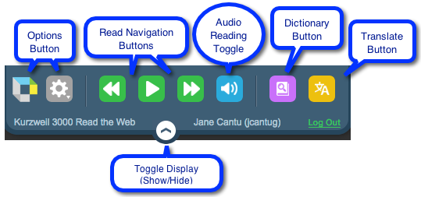8. Your Read the Web Toolbar is opened and ready to use.