

**Program Integrated Planning and Review-Resource Allocation Handbook and curriQunet Manual**

**Administrative and College Services**

**2021-2022**

This page left intentionally blank

Gavilan College

Program Integrated Planning and Review,

Resource Allocation Process Handbook – Administration and College Services  
Academic Year 2021-22

Contents

**Introduction** 5

Your Support Team: 5

**2020-21 Timeline**: 6

Program Integrated Planning and Review Purposes, Scope, Structure and Process 7

Purpose 7

Scope 7

Committee Structure and Role 7

Process 8

Accreditation Standards 9

Overview of the PIPR-RAP-RAP Cycle 10

Participation in Program Integrated Planning and Review 11

General Suggestions for a Successful Report 12

Access to and Interpretation of Supporting Evidence 12

Examples of High-Quality Documents 12

What Happens Next? 13

Implementation and Documentation 13

Continuous Quality Improvement of the Program Integrated Planning and Review Process 13

Access and Log In 15

Creating your Proposal 16

How to Retrieve your Proposal 19

Navigating your Program Review Proposal Template 20

Main Tab 20

Navigating Through curriQunet 21

Co-Contributors 21

Completing the Report 21

Launch Indicators 21

Program Review Questions 23

Program Mission and Accomplishments 23

Gavilan College Mission Statement 23

Response and follow-up to previous program reviews 23

Student and Program Outcomes 23

College Goal for Student Achievement 23

Equity 23

Learning and Area Outcomes 24

Outcome Assessments 24

Services Area Outcomes (SAO) 24

Institutional Learning Outcomes (ILO) 24

Program and Resource Analysis 24

Evaluation of Resource Allocations 25

Program Productivity 25

Program Productivity Measurements 25

Year and Student count 25

Integrated Planning and Initiatives 25

Other Opportunities and Threats 25

Additional Questions 25

Goals 26

Three-Year Program Plan Goals 26

Executive Summary 26

# **Introduction**

The purpose of this Program Integrated Planning & Review, Resource Allocation Process (PIPR-RAP) Administrative Services Handbook is to:

* Describe the purposes, scope, and structure of the PIPR-RAP process.
* Explain the evaluation processes for program review.
* Provide guidance as you review the last three years of your program and create goals for the next three years
* Describe the institutional priorities process that relies on the program review and annual planning documents.
* Understand the intersection of Program Review and Resource allocation and the committee work for both.

The handbook is reviewed and revised annually by the PIPR-RAP Committee, in response to users’ requests for clarification and enhancement.

This handbook, the PIPR-RAP schedule~~, the forms~~, and references used in the process, may be downloaded from the [PIPR-RAP Website](http://www.gavilan.edu/staff/program_planning/index.php).

**Contacts:**

Erin Crook, Committee Co-Chair [ecrook@gavilan.edu](mailto:ecrook@gavilan.edu)

Denee Pescarmona, Committee Co-Chair [dpescarmona@gavilan.edu](mailto:dpescarmona@gavilan.edu)

## Your Support Team:

|  |  |  |
| --- | --- | --- |
| Program | Author | Support Team |
| Admissions and Records | Candice Whitney | Susan Sweeney, Kim Benjamin, David Argudo |
| ASGC |  | Veronica Martinez,  Simone Reyes |
| Business Services | Michelle Anaya | Sydney LaRose, Ozzy Zamora, Grace Cardinalli |
| Non-Instructional Divisions:  RPIE | Sydney LaRose | Erin Crook, Debbie Klein, Jane Maringer |
| Facilities | Jeff Gopp | Sydney LaRose, Ozzy Zamora,  Grace Cardinalli |
| Gavilan Foundation | Jan Bernstein-Chargin | Erin Crook, Debbie Klein, Jane Maringer |
| Human Resources | Lucy Alvarez | Veronica Martinez,  Simone Reyes |
| IT | Kyle Billups | Susan Sweeney, Kim Benjamin, David Argudo |
| PIO | Jan Bernstein-Chargin | Erin Crook, Debbie Klein, Jane Maringer |
| Hollister Campus | Judy Rodriguez | Susan Sweeney, Kim Benjamin, David Argudo |
| Security and Support Services | Graciano Mendoza | Erin Crook, Debbie Klein, Jane Maringer |

# **2020-21 Timeline**:

Refer to the timeline for due dates and process instructions. You will receive periodic email reminders from your support teams regarding upcoming deadlines. Programs that do not complete their PIPR document and Goal-Setting Worksheet will be required to complete a program review in the following year and funding requests will not be considered.

|  |  |  |  |  |  |
| --- | --- | --- | --- | --- | --- |
| **AY 2021 -22** | | **Description** | | **Did You:** | |
| **2021** | | | | | |
| May | | Administrative Program authors Orientation, including website ‘tour’, Tableau, curriQunet and other data site overview; introduction to support teams (5/24). | | * Attend orientation | |
| June | | Committee Chairs presents annual report to Board of Trustees (6/8) | |  | |
| September | | Authors invited to attend Committee meeting for brush-up orientation, if needed (9/13)    Authors seek assistance from support team, department faculty, Dean, others to gather information for report    Write Proposal draft (first draft due Thursday, Nov. 11).    Periodic check-ins with support team. | | * Attend refresher orientation * Add co-authors in CurriQunet * Check in with your support team? | |
| October | | Workshop (10/11), 1:00 – 2:00    Schedule appointment with your Dean/ Supervisor to review 3-year plans and goals.    **By 10/29**, Meet with area dean to discuss program/ department plans, goals and resource allocation requests. | | * Attend workshop * Schedule a meeting with your supervisor? * Meet with Supervisor? | |
| November | | Workshop (11/8), 1:00 – 2:00  Initial draft due (11/11)  Peers review report (11/15-19)  Draft revision begins (11/22) | | * Attend workshop * Peer review report and send feedback to author? | |
| December | | Proposals launched in CurriQunet by end of the semester: Programs and Departments: 12/11  Deans: 12/22  VPs: 1/14 | | * Launch proposal | |
|  | |  | |  | |
| **Winter Break** | | Resource requests reviewed at Deans Council for Integration opportunities | |  | |
| **2022** | | | | | |
| February | | Resource allocation prioritization process begins (2/14) | |  | |
| March | | PIPR-RAP completes resource allocation prioritization (3/14)    Authors receive results of ranking (by 3/28) | |  | |
| April | | Authors attend committee meeting to discuss strengths, weaknesses of process (4/11) | |  | |
| May | | Instructional Authors receive training for next cycle (5**/**9)  Committee Chairs report to President's Council (5/11) | |  | |
| June 14 | | Committee Chairs presents annual report to Board of Trustees | |  | |

# Program Integrated Planning and Review Purposes, Scope, Structure and Process

## Purpose

The fundamental purpose of ongoing program review and planning is to maintain and if possible, improve the effectiveness of every College program and service, and of the institution as a whole, based on the results of regular, systematic assessment. The ultimate beneficiaries of program integrated planning and review are our students and the community we serve. The Program Integrated Planning and Review- Resource Allocation Process (PIPR-RAP) Committee’s work is to shepherd authors through the writing process to create a document, completed on time, that accurately reflects their programs, and to rank resource requests generated from these documents.

Specifically, program review facilitates:

* Creation of a three-year plan for each program
* Resource allocation requests for the **next three fiscal years**.
* Institutional & program improvement through the comprehensive self-study, peer review, and planning process
* Development of a three-year resources request plan, including data to support annual financial requests
* Creation of a living document that provides all basic information and forward planning for each program; can be referenced by stakeholders via public website
* Program leadership continuity of expertise (e.g., a department chair or leadership change)
* A baseline for the integrated planning process and cycle
* Identify programs that may be forwarded to Academic Senate for program viability assessment
* Accreditation compliance; board policy / administrative procedure compliance (c.f[. BP/AP 4020](http://www.gavilan.edu/administration/board/documents/ApprovedChapter4BPAP.pdf), BP/AP 6200)

Another purpose is to focus available resources—staff time, budget, technology, space - on the achievement of goals and objectives intended to maintain or improve effectiveness of the program itself, but also the programs’ contribution to the College’s Strategic Plan. Achieving some objectives requires resources over and above what is available, which means that a resource request is necessary; achieving others requires no extra resources—only the reallocation of existing ones.

## Scope

The PIPR-RAP process applies to every unit in the College. This includes all programs in Instruction, Student Services, Administrative Services, and the President’s Area.

## Committee Structure and Role

The PIPR-RAP Committee coordinates and supports the PIPR-RAP process every year. The PIPR-RAP Committee:

* Provides author training on, and support through planning and review, document completion.
* Establishes the schedule.
* Ranks resource requests on college-wide resource priorities and provides ranking list to the Business Office.
* Informs Academic Senate, reports to President’s Council and the Board of Trustees on the health or effectiveness of all programs that complete program review; notes any that are exemplary as well as any that require assistance from senior management to improve.
* Evaluates annually: the forms used in the process, all documentation (including this handbook), and implementation of the process itself, and makes recommendations for continual improvement.

The Committee is co-chaired by the Vice President of the Administration Services or designee, and a faculty member. Its membership includes representatives from faculty, classified professionals, management, and students. The Research, Planning and Institutional Effectiveness Division maintains the Committee archives.

## Process

Central to the whole process are the program units themselves, who devote much time and energy to evaluating their own performance, identifying needed improvements, setting goals and objectives accordingly, and implementing those improvements in a continuous cycle.

The program author is charged with ensuring that the unit’s integrated planning or program review process is completed properly and in timely fashion.

For most programs within Instruction, faculty chairs, coordinators, directors, and deans, as applicable, are the program leads.

For an instructional program with no full-time faculty, the program lead is the applicable dean or designee in collaboration with a part-time faculty member who will receive compensation.

For each program within Student Services, the program lead is the director or dean.

For each program that supports the college overall (College Services which includes all of Administrative Services, RPIE, Human Resources, etc.), the program lead is the supervisor (working collaboratively with leads to the extent feasible).

For those departments reporting directly to the President, the program leads are the directors and/or associate vice presidents.

If the regular lead for a given program is not available, then the program lead’s responsibility becomes that of the lead’s supervisor. For example, if a directorship is vacant, then the lead is the dean or Vice President to whom that director reports.

The Vice President or Dean can delegate authorship as appropriate.

# Accreditation Standards

The Accrediting Commission for Community and Junior Colleges (ACCJC) sets standards for two-year institutions in California, Hawaii, and the Pacific. To retain its accreditation, every college must demonstrate that it meets those standards. Nearly all the standards have planning and evaluation components, but the following is the one most closely related to planning and program review and its relationship with resource allocation:

**Standard IB: Assuring Academic Quality and Institutional Effectiveness**

The institution demonstrates strong commitment to a mission that emphasizes student learning and student achievement. Using analysis of quantitative and qualitative data, the institution continuously and systematically evaluates, plans, implements, and improves the quality of its educational programs and services. The institution demonstrates integrity in all policies, actions, and communication. The administration, faculty, staff, and governing board members act honestly, ethically, and fairly in the performance of their duties.

**Academic Quality**

1. The institution demonstrates a sustained, substantive and collegial dialog about student outcomes, student equity, academic quality, institutional effectiveness, and continuous improvement of student learning and achievement.
2. The institution defines and assesses student learning outcomes for all instructional programs and student and learning support services.
3. The institution establishes institution-set standards for student achievement, appropriate to its mission, assesses how well it is achieving them in pursuit of continuous improvement, and publishes this information.
4. The institution uses assessment data and organizes its institutional processes to support student learning and student achievement.

**Institutional Effectiveness**

1. The institution assesses accomplishment of its mission through program review and evaluation of goals and objectives, student learning outcomes, and student achievement. Quantitative and qualitative data are disaggregated for analysis by program type and mode of delivery.
2. The institution disaggregates and analyzes learning outcomes and achievement for subpopulations of students. When the institution identifies performance gaps, it implements strategies, which may include allocation or reallocation of human, fiscal and other resources, to mitigate those gaps and evaluates the efficacy of those strategies.
3. The institution regularly evaluates its policies and practices across all areas of the institution, including instructional programs, student and learning support services, resource management, and governance processes to assure their effectiveness in supporting academic quality and accomplishment of mission.
4. The institution broadly communicates the results of all of its assessment and evaluation activities so that the institution has a shared understanding of its strengths and weaknesses and sets appropriate priorities.
5. The institution engages in continuous, broad based, systematic evaluation and planning. The institution integrates program review, planning, and resource allocation into a comprehensive process that leads to accomplishment of its mission and improvement of institutional effectiveness and academic quality. Institutional planning addresses short- and long-range needs for educational programs and services and for human, physical, technology, and financial resources.

**Standard IIID: Financial Resources**

**Planning**

1. Financial resources are sufficient to support and sustain student learning programs and services and improve institutional effectiveness. The distribution of resources supports the development, maintenance, allocation and reallocation, and enhancement of programs and services. The institution plans and manages its financial affairs with integrity and in a manner that ensures financial stability.

# Overview of the PIPR-RAP-RAP Cycle

The PIPR-RAP process is a three-year cycle, as shown in the diagram below:

Each unit will perform a full program review every third year. Program plans and goals are based on the College’s Strategic Plan. Program activity and resource requests are based on these three-year plan goals.

Once the PIPR-RAP document has been completed, a process begins to discuss goals and resource requests.

Each area implements any necessary improvements that it has identified, assesses its progress, and the cycle continues. The less detailed annual update serves to update your program plan. Units update their Three-Year Plan—with progress toward goals, objectives, actions, and (where appropriate) resource requests—every year.

See the *Completing the Report* section for information on all document content prepared for program review.

# Participation in Program Integrated Planning and Review

All unit members in collaboration with their department chair (in instructional programs) or area manager (in all other college units) and with the guidance of their dean, completes the three-year program plan, and develops measurable three-year goals with resource requests. All unit members should work with their dean to ensure that the quality of their document is at least adequate for submission and their plans are aligned with the division/ college goals.

Broad participation in program integrated planning and review, as with any shared-governance activity, is an important contributor to the effectiveness of the process. The program lead should invite all members including managers, full- and part-time faculty and classified professionals to participate in the preparation and/or review of each program review and planning report.

In addition, at least one representative of each primary group of the area should be invited to participate in the preparation and/or review of each program review and planning document. Programs offering instruction or services to students should always invite at least one student to serve as a participant or reviewer. Programs offering services to faculty, managers, and/or classified professionals should always invite at least one from this constituency to serve as a participant or reviewer. Additional participants (e.g., community members, business representatives) may be added as appropriate at the area’s discretion.

# General Suggestions for a Successful Report

Suggestions for authors to create their best document, accurately reflecting their area:

1. **Start early** and set aside ample time to discuss the issues related to planning and program review, add to draft, review, and revise your answers to the questions. The difference between an outstanding program plan and a poorly written one often boils down to the amount of time devoted to the process. On the other hand, it is counterproductive to spend excessive time on the process. Try to strike a reasonable balance.
2. Length of Responses

Please answer all questions thoughtfully, fully, and accurately, and be as concise as possible. Number of characters in each response is limited to 1,200 characters (approximately 300 words).

1. Use the resources available
   1. “Exemplary” program document examples posted on the [Resources Page](https://www.gavilan.edu/staff/program_planning/Links_FAQs.php) of the PIPR-RAP website.
   2. Attend orientation and any group work time that has been scheduled (see timeline for specific dates and times). During these work times, the PIPR-RAP Chair can give assistance regarding:
      1. SMART Goal Setting
      2. Access to and Interpretation of Data
      3. Aligning Goals to the Strategic Plan
   3. If you are stuck at any point in the process, contact your [PIPR-RAP Support Team](http://www.gavilan.edu/staff/program_planning/Committee_Information.php) and ask for help. They are your partner in this process and are available to answer your questions.
2. Define any acronyms you use in your documents so others reading can understand your meaning.
3. Make your document meaningful. You are creating your departmental plan for the next three years. Refer to the College’s [Strategic Plan goals and activities](http://www.gavilan.edu/administration/master_plan/docs/SP_GoalsStrategiesDraft-final.pdf) as you create program/ departmental goals.

## Access to and Interpretation of Supporting Evidence

Throughout the report you will have prompts directing you to external data (Tableau, Chancellor’s Office resources, etc.). Your support team will be meeting with you to assist in accessing, interpreting and integrating data into your review and plans.

## Examples of High-Quality Documents

Before you begin preparing your program review in earnest, review exemplary submissions from prior cycles posted on the [PIPR-RAP website](https://www.gavilan.edu/staff/program_planning/Links_FAQs.php).

# What Happens Next?

Once the report is finalized, it is launched and electronically sent to the area dean, director and/or supervisor. Once approved by the supervisor, your document is complete and will be published on the PIPR-RAP page of the Gavilan College’s external website.

Deans will work together in Deans Council to identify where collaboration of projects might take place and discuss resource requests. Outcomes of the Deans Council discussions will be forwarded to Cabinet for discussion. Resource requests will be reviewed by the PIPR-RAP Committee for ranking. Once ranked, the committee co-chair will inform authors of results and ranking of their resource requests.  These resource requests will be reviewed and implemented as part of the tentative budget process (see [Budget Planning Calendar](http://www.gavilan.edu/administration/budget/index.php)).

In May, the PIPR-RAP Committee faculty co-chair will present a report to Academic Senate and President’s Council and in June, to the Board of Trustees. The report will include which areas went through the PIPR-RAP process in the academic year, results of the process, evaluation, suggested improvements to be made in the following cycle, and include specific report information such as:

* A summary of this year’s process and overall findings.
* All units 3-year Program Plans

## Implementation and Documentation

All units are expected to take the necessary steps to achieve the goals and objectives they have identified in their *Goals Section* according to the timelines and priorities they have specified. Actions under ‘Objectives’ contingent on the unit’s receipt of requested resources may be delayed if those resources are not available. The unit should first turn its attention to those objectives that do not require additional resources. When general fund resources are not available, the committee will discuss how other categorical funds may be requested, appropriate SMART goals

Annual updates to the PIPR-RAP plan are part of the planning and review cycle. Areas must document their progress on each objective annually to ensure that the status report on goals and objectives in the next planning and program review cycle is complete. Failure to provide an annual update may result in loss of funding for the activities.

## Continuous Quality Improvement of the Program Integrated Planning and Review Process

Each spring, after the program review process and resource allocation ranking for the cycle are complete, the PIPR-RAP Committee evaluates those processes, identifies any needed improvements, and implements those improvements in the next cycle. The primary elements of the evaluation include the following:

1. All members from all units who participated in Program Review during the current cycle are asked to provide their opinion of the clarity, usefulness, and other characteristics of the process. Suggestions to programs that will participate in the process next year, recommendations for improving the process, and any other suggestions or comments are welcome
2. Identification of training needs for participants and managers, and scheduling of training sessions.
3. The review and, if necessary, revision of internal committee procedures, including meeting schedules.
4. The review and, if necessary, revision of forms, website contents, and this handbook.

**The Resource Allocation Process and Implementation Cycle**

Plans and Goals align to:

Strategic Plan/ strategic goals

Mission Statement

SAOs/ SLOs

Feedback

Feedback

Feedback

Feedback

June 2017

# Access and Log In

You can access curriQunet through the Intranet tab in MyGav.

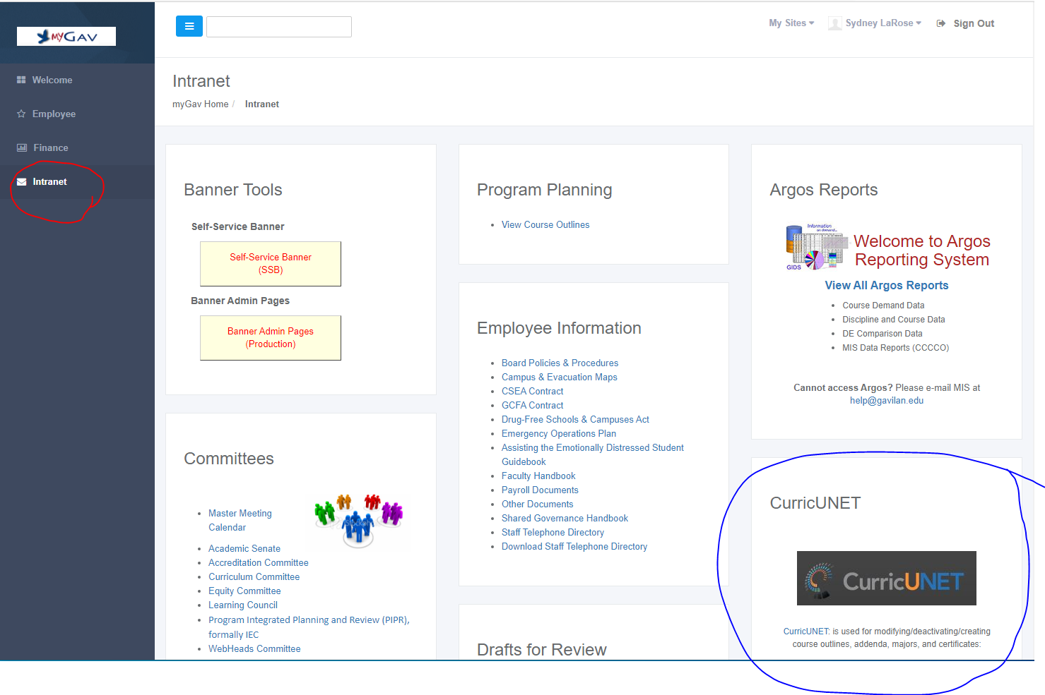

## Creating your Proposal

1. This is curriQunet’s home page. Press ‘Create Proposal’

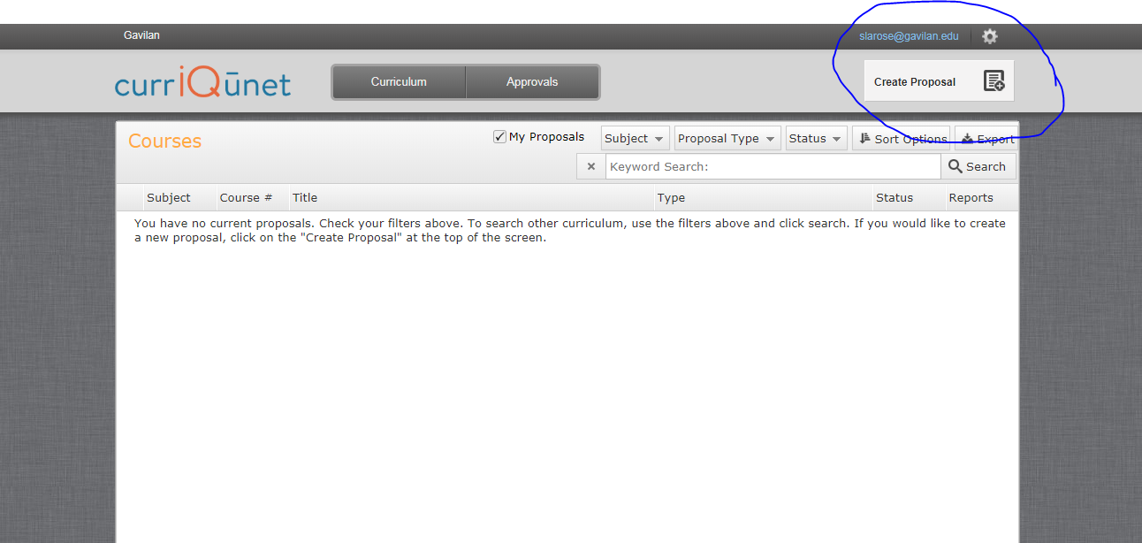

2. Select ‘Program Reviews’ from the drop down menu. Press Next

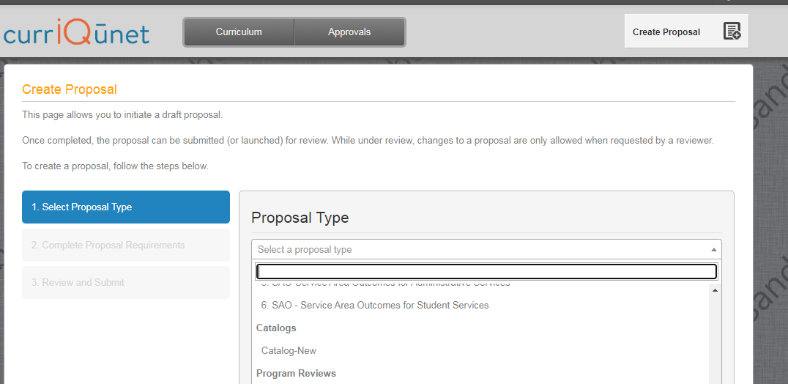

3. Select your program/ department/ area from the drop-down menu. Your view might look slightly different. In the ‘Module Title’ cell, name your program review document. A suggested name might be your Program Name and Academic year, e.g. RPIE, 2021-22. Press ’Next’.

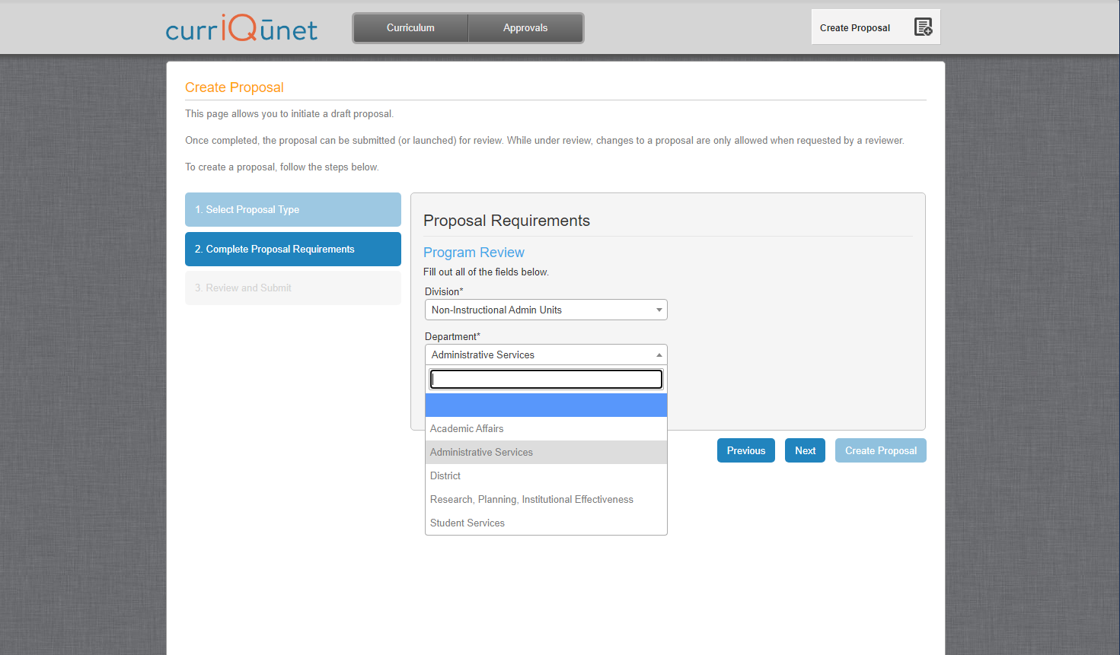

4. On the next screen press ‘Create Proposal’.

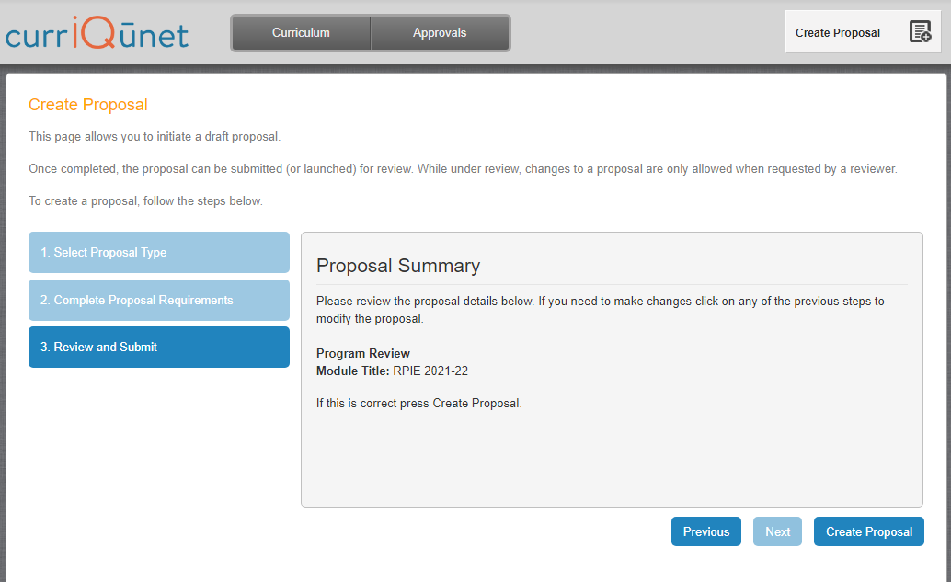

# How to Retrieve your Proposal

1. Access curriQunet from the intranet tab in MyGav

2. On the grey bar at the top, click on ‘Curriculum’ and select Program Reivew

3. Make sure the ‘My Proposals’ box is checked

4. Press Search

5. All proposals you have authored will appear in the window. Select the current proposal.

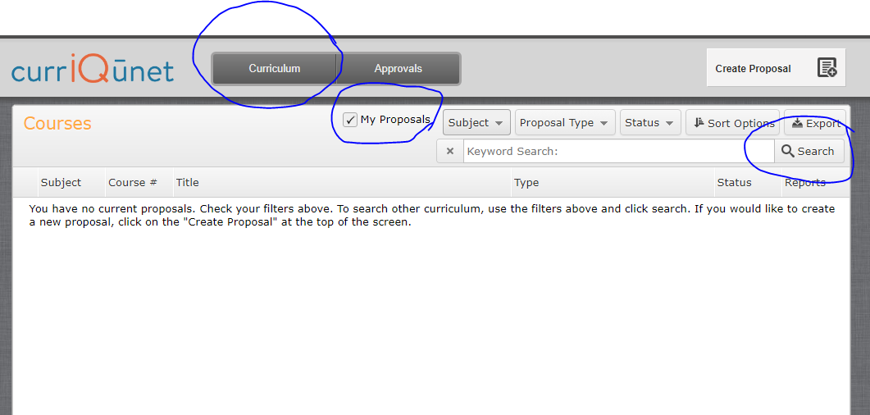

# Navigating your Program Review Proposal Template

## Main Tab

The Program Review Proposal opens to the Main Tab. Move between sections using the dark gray tabs to the far left. Sections with required fields also have an orange box showing your progress, which will turn green when you have completed all required fields. After completing all fields in the “Main” section, save any changes. Throughout the proposal you will only be prompted to save if changes are made. **Always remember to hit the save button or your work will be lost.** On this main page, select the academic year and program from the drop-down menu. The Program Type will auto populate, indicating what manual you will use. Press Save.

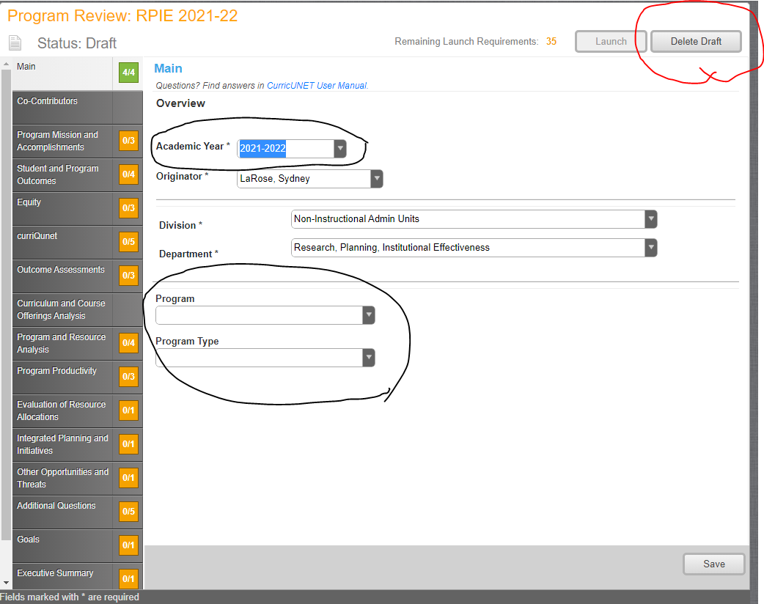

Will delete ALL your work

**The ‘Delete Draft’ button at the top right will delete your entire proposal and you will need to begin everything from scratch. It is recommended that you do not press this.**

**The ‘Launch’ button is pressed when you have completed all sections of your Program Review and you are ready to submit your work.**

## Navigating Through curriQunet

Move between sections using the dark gray tabs to the far left. You must manually select each section to complete. Click on the text, not the box. Sections with required fields have an orange box showing your progress, and will turn green when all required fields have been completed. Throughout the proposal you will only be prompted to save if changes are made. Always remember to hit the save button at the bottom of the page or your work will be lost.

## Co-Contributors

Co-contributors are colleagues to whom you are giving editing/ collaboration permissions. This may include people in your department and others assisting you in writing your report.

Select people from the co-contributor list. If you don’t see someone listed, please contact [Sydney LaRose](mailto:slarose@gavilan.edu) and she will add them. Press ‘Save’ once done.

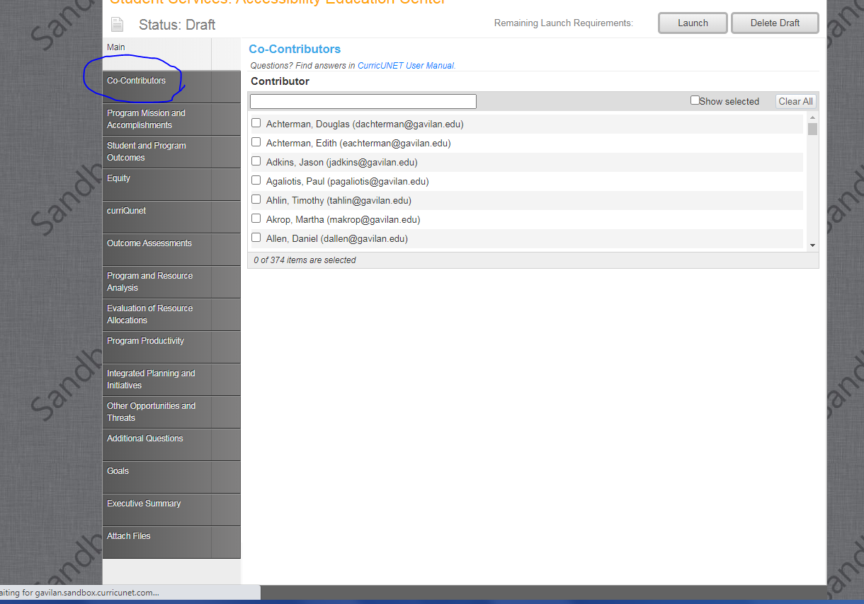

## Completing the Report

From this point forward, you are completing each section of your Program Review. All questions require an answer in order to complete the section. If a question does not pertain to your area, N/A is an appropriate response. Each text section has a word limit of approximately 1,200 characters (approximately 300 words). Brief yet thorough statements are recommended.

## Launch Indicators

Launch indicators are your clue to what is required to complete each question.

* You will see indicators informing you ‘**a value must be provided before launching’**. Translation: **‘Fill in this section’**.
* Some questions are formatted in such a way that you will need to press an ‘add item’ button in order to load the question into the system.
  + Add Item(s): Sometimes you will need to press the ‘add item’ button once to complete the question. Other times you are being asked a multi-year question and will need to “add an item”, fill in the information for one year, and repeat the process twice more to complete the answer for all years. Your Launch Requirement will inform you on what is needed.

As always, if you have questions, contact your [support team](http://www.gavilan.edu/staff/program_planning/Author%20and%20Support%20Team%20Assignments.php) for assistance.

# Program Review Questions

## Program Mission and Accomplishments

### Gavilan College Mission Statement

Gavilan College actively engages, empowers and enriches students of all backgrounds and abilities to build their full academic, social, and economic potential.

Provide a brief overview of how the program contributes to accomplishing the mission of Gavilan College. In addition to a basic overview of your program’s structure and services, be specific in connecting your program’s services to elements of the mission statement (300 words or less).

On the PIPR website, locate and review your previous program plan and subsequent annual updates. After studying, please list

Previous Goals and Accomplishments:

## Response and follow-up to previous program reviews

Have the services of your program changed over the past three years? Please explain (300 words or less).

## Student and Program Outcomes

### College Goal for Student Achievement

The following questions refer to data regarding student achievement.

How many students did your area serve (if you don’t have an exact count, please provide an estimate)? How did they perform in comparison to those that did not use your services, if applicable? Given this information, how has your service or area supported student success and retention over the past three years (200 words or less)?

See Success and Retention dashboard in Tableau's Program Review section.

In your area, what goals need to be set and what initiatives need to be developed to support success and retention? (200 words or less).

## Equity

Gavilan College has identified the following populations as experiencing disproportionate outcomes: Males, African American, Native American, Students with Disabilities and Foster Youth.

For EOPS/ CalWORKs, MESA, TRiO, Puente, and VRC: LOCATE Success and Retention dashboard in Tableau's Program Review section. Examine your equity results over the last three years. If there are differences in success rates and/ or retention across groups, comment on any differences in success rates across groups. Helpful Questions: What current factors or potential causes can be connected to these areas of disproportional impact? How might your program or department address student equity gaps (200 words or less)?

For all other areas, how can your area help increase disproportionate student success? Contact your support team for any needed assistance in interpreting these data (200 words or less).

Please find Equity information in Tableau's Success and Retention dashboard. Contact your support team for any needed assistance in using Tableau.

Our Equal Employment Opportunity (EEO) Plan States

"Ensuring equal employment opportunity involves creating an environment that fosters cooperation, acceptance, democracy, free expression of ideas and is welcoming to persons of all gender expressions, persons with different abilities, and individuals from all ethnic and other groups protected from discrimination."

What is your area doing to support district efforts in creating an inclusive college environment? With what departments are you partnering? Did you identify barriers and institute change? How is you creating/ ensuring diversity in your department or in the classroom?

Some examples might be sponsoring cultural events and diverse speakers on issues dealing with diversity, exploring how to infuse diversity into the classroom and curriculum, integrating diversity into the evaluation of employees, promoting learning opportunities and personal growth in the area of diversity, or evaluating how the physical environment can be responsive to diverse employee and student populations.

How do you plan on addressing issues of student and employee equity? In other words, how do you plan on creating opportunities for success of students who have historically been underserved? How do you plan to address EEO outcomes in your employee hires?

## Learning and Area Outcomes

Have you reviewed all of your Service Area Outcomes (SAOs) to ensure that they remain relevant for evaluating the performance of your area?

* Are your SAOs mapped in curiQunet?
* Are your SAOs up to date in curriQunet?
* Have your SAOs been assessed in the last five years?
* Have you reviewed all of your SAOs to ensure that they remain relevant for evaluating the performance of your area?

If you answered no to any of the above questions, what is your plan to bring your assessments into compliance (200 words or less)?

## Outcome Assessments

### Services Area Outcomes (SAO)

Review your SAOs data located in curriQunet. What is your department's acceptable achievement score goal for each outcome?

### Institutional Learning Outcomes (ILO)

How do your SAO support the college ILOs? Be specific (200 words or less).

Are you meeting your SAO success goals? What patterns stand out in your results? If your SAO results are lower than your goals, what are your plans to improve them (200 words or less)?

## Program and Resource Analysis

Please list the number of Full and Part Time faculty, staff and/ or managers/ administrator positions in this program over the past three years. Focus on your individual program. ***Faculty Percentages box will auto-populate***.

How have and will those with reassigned time, grant commitments and activity, projected retirements and sabbaticals affect personnel and load within the past in the next three years? What future impacts do you foresee (200 words or less)?

## Evaluation of Resource Allocations

List the resource allocations from all sources (e.g., annual college budget request appropriations, Guided Pathways funds, grant funds, etc.) received in the last three years. For annual college budget request appropriations, reference your previous three-year plan and annual updates.

Please evaluate the effectiveness of the resources utilized for your program. How did these resources help student success and completion? For college budget request appropriations, list the result of the evaluation strategy outlined in your previous three-year plan and annual updates. For all other sources of funding, list the results of the evaluation strategy contained within the program or grant plan.

Did you receive additional funds?

If Yes, please provide resources allocated, funding source, academic year, purpose of funding and result.

## Program Productivity

### Program Productivity Measurements

Determine the number of students you assist annually. Using the data provided by the business office, calculate your average cost effectiveness per student. **If you do not have student contact, please fill out Total allocated budget and Total spending.**

### Year and Student count

Evaluate your program costs. Are your costs in alignment with your budget? If not, what improvements can be made? Please explain any trends in spending, inconsistencies and unexpected results.

## Integrated Planning and Initiatives

What other areas is your program partnering with (i.e. guided pathways, grant collaboration, etc.) in new ventures to improve student success at Gavilan College? What is the focus of this collaboration? Helpful question: What are the department and your Integrated Planning/ Guided Pathways partners’ plans for the next three years (200 words or less)?

## Other Opportunities and Threats

Review for opportunities or threats to your program, or an analysis of important subgroups of the college population you serve. Examples may include environmental scans from the Educational Master Plan, changes in matriculation or articulation, student population, community and/ or labor market changes, EMSI data and etc. Helpful Question: What are the departmental plans for the next three years (200 words or less)?

## Additional Questions

Please consider providing answers to the following questions. While these are optional, they provide crucial information about your equity efforts, training, classified professional support, and recruitment.

1. Does your division (or program) provide any training/mentoring for faculty and/ or classified professionals regarding professional development?
2. If there is a need for more faculty and/ or classified professional support in your area, please provide data to justify request. Indicate how it would support the college mission and college goals for success and completion.
3. What, if anything, is your program doing to assist the District in attracting and retaining faculty and classified professionals who are sensitive to, and knowledgeable of, the needs of our continually changing constituencies, and reflect the make-up of our student body?
4. Are there program accomplishments/ milestones that have not been mentioned that you would like to highlight?

Please share any recommendations for improvements in the Program Integrated Plan and Review process, analysis, and questions. Your comments will be helpful to the PIPR Committee and will become part of the permanent review record.

## Goals

### Three-Year Program Plan Goals

Goal

Connection of Goal to Mission Statement, Strategic Plan and SAO results

Proposed Activity to Achieve Goal

Responsible Party

Fund amount requested. If a collaboration, what percentage required from each partner?

Total three-year resource allocation request

Timeline to completion (month/ year)

How will you evaluate whether you achieved your goal?

## Executive Summary

Please provide a brief executive summary regarding program trends and highlights that surfaced in the writing of this report. Summarize, using narrative, your program goals for your next three years. Your audience will be your Peer Review Team, the PIPR Committee, President’s Cabinet, Dean’s Council, ASGC, Academic Senate, Budget Committee and Board of Trustees (300 words or less).