

**curriQunet Manual**

**for PIPR-RAP**

This page left intentionally blank

Gavilan College

PIPR-RAP curriQunet Handbook

Contents

Access and Log In 4

Creating your Proposal 5

How to Retrieve your Proposal 7

Navigating your Program Review Proposal Template 8

Main Tab 8

Navigating Through curriQunet 9

Co-Contributors 9

Completing the Report 9

Launch Indicators 9

# Access and Log In

You can access curriQunet through the Intranet tab in MyGav.

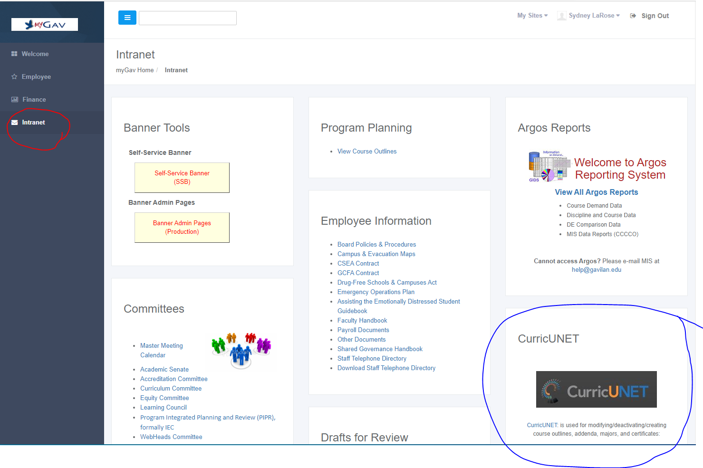

## Creating your Proposal

1. This is curriQunet’s home page. Press ‘Create Proposal’

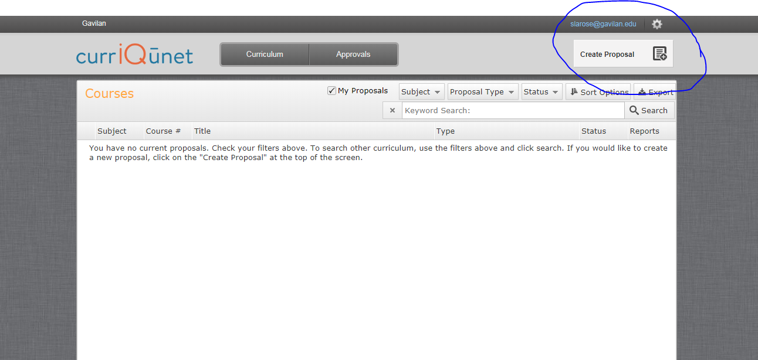

2. Select ‘Program Reviews’ from the drop down menu. Press Next

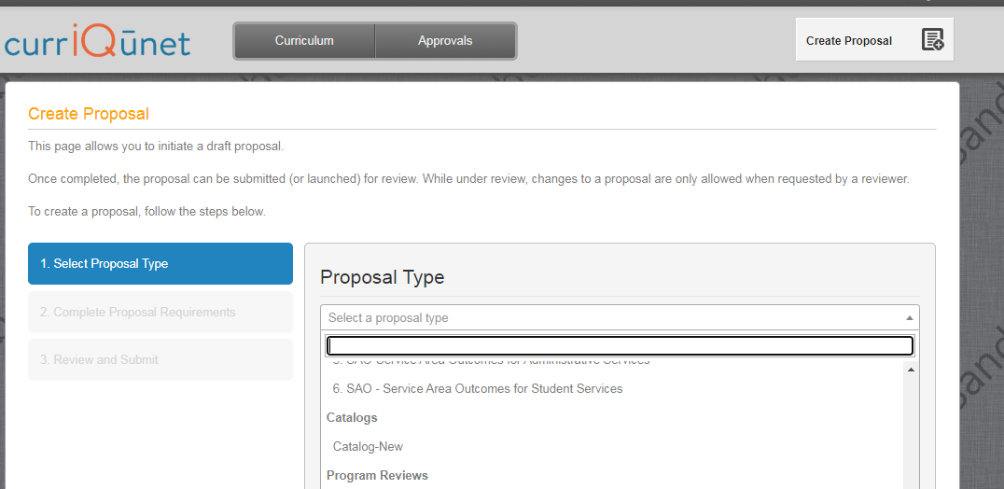

3. Select your program/ department/ area from the drop-down menu. Your view might look slightly different. In the ‘Module Title’ cell, name your program review document. A suggested name might be your Program Name and Academic year, e.g. RPIE, 2021-22. Press ’Next’.

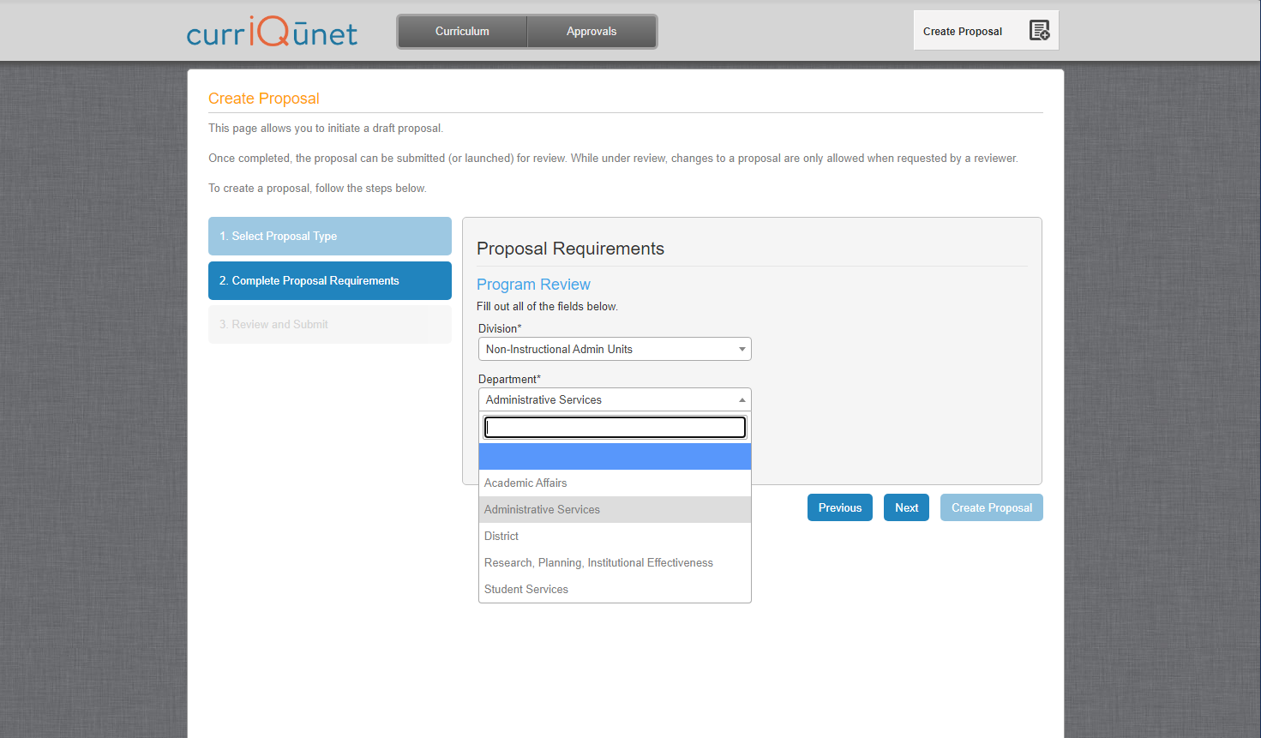

4. On the next screen press ‘Create Proposal’.

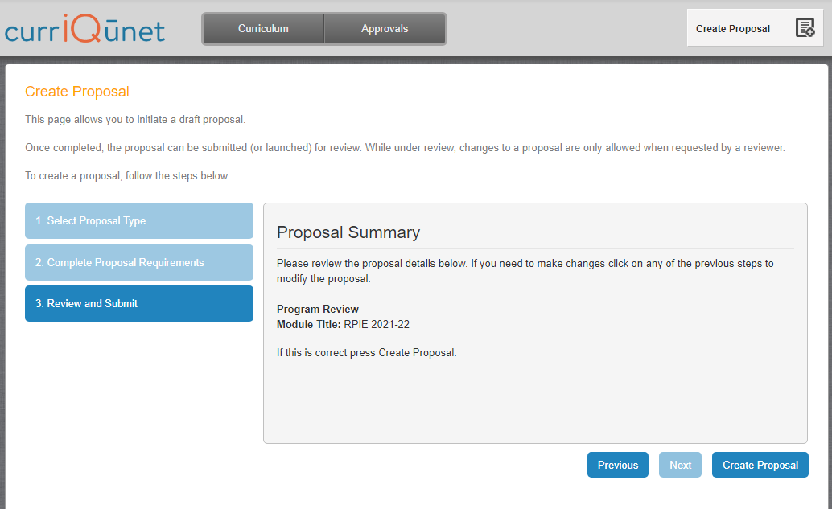

# How to Retrieve your Proposal

1. Access curriQunet from the intranet tab in MyGav

2. On the grey bar at the top, click on ‘Curriculum’ and select Program Reivew

3. Make sure the ‘My Proposals’ box is checked

4. Press Search

5. All proposals you have authored will appear in the window. Select the current proposal.

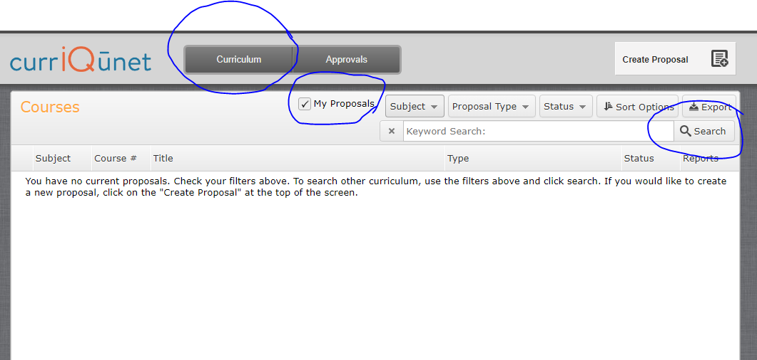

# Navigating your Program Review Proposal Template

## Main Tab

The Program Review Proposal opens to the Main Tab. Move between sections using the dark gray tabs to the far left. Sections with required fields also have an orange box showing your progress, which will turn green when you have completed all required fields. After completing all fields in the “Main” section, save any changes. Throughout the proposal you will only be prompted to save if changes are made. **Always remember to hit the save button or your work will be lost.** On this main page, select the academic year and program from the drop-down menu. The Program Type will auto populate, indicating what manual you will use. Press Save.

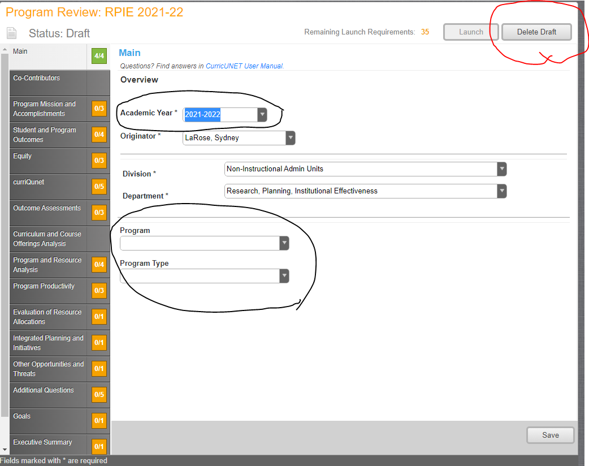

Will delete ALL your work

**The ‘Delete Draft’ button at the top right will delete your entire proposal and you will need to begin everything from scratch. It is recommended that you do not press this.**

**The ‘Launch’ button is pressed when you have completed all sections of your Program Review and you are ready to submit your work.**

## Navigating Through curriQunet

Move between sections using the dark gray tabs to the far left. You must manually select each section to complete. Click on the text, not the box. Sections with required fields have an orange box showing your progress, and will turn green when all required fields have been completed. Throughout the proposal you will only be prompted to save if changes are made. Always remember to hit the save button at the bottom of the page or your work will be lost.

## Co-Contributors

Co-contributors are colleagues to whom you are giving editing/ collaboration permissions. This may include people in your department and others assisting you in writing your report.

Select people from the co-contributor list. If you don’t see someone listed, please contact [Sydney LaRose](mailto:slarose@gavilan.edu) and she will add them. Press ‘Save’ once done.

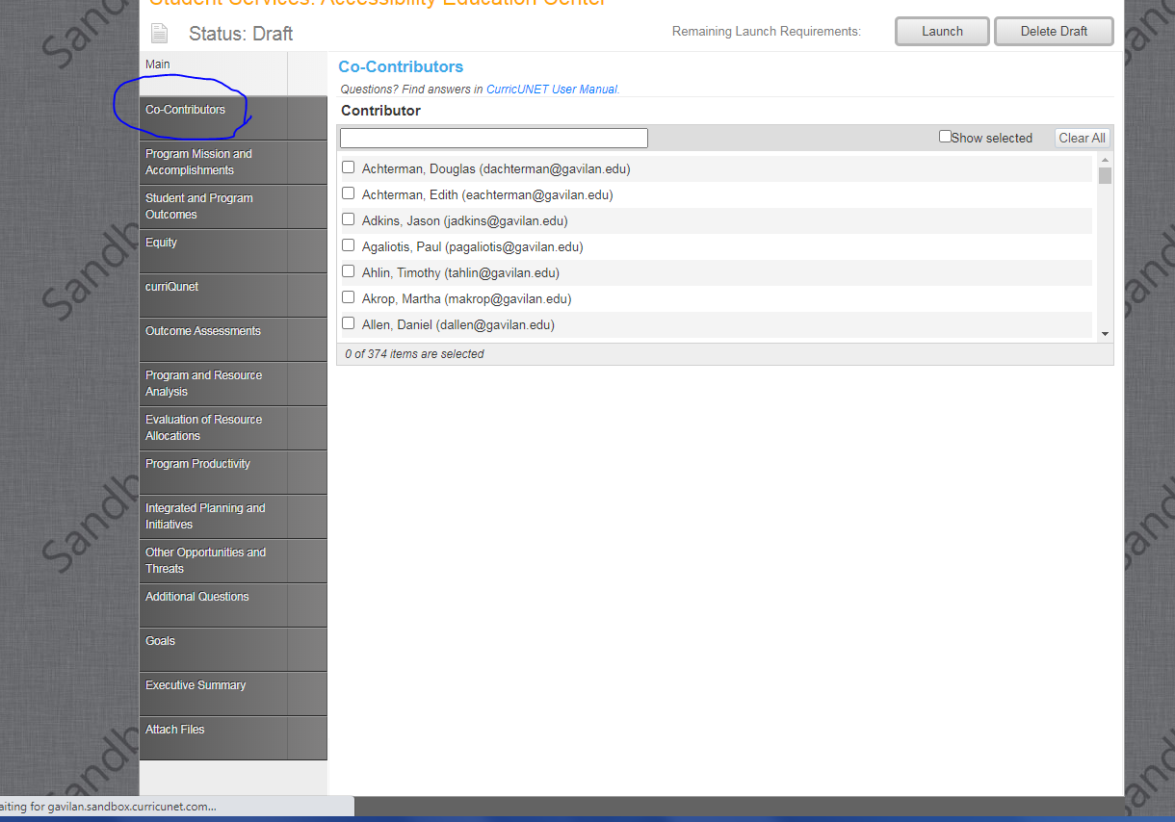

## Completing the Report

From this point forward, you are completing each section of your Program Review. All questions require an answer in order to complete the section. If a question does not pertain to your area, N/A is an appropriate response. Each text section has a word limit of approximately 1,200 characters (approximately 300 words). Brief yet thorough statements are recommended.

## Launch Indicators

Launch indicators are your clue to what is required to complete each question.

* You will see indicators informing you ‘**a value must be provided before launching’**. Translation: **‘Fill in this section’**.
* Some questions are formatted in such a way that you will need to press an ‘add item’ button in order to load the question into the system.
  + Add Item(s): Sometimes you will need to press the ‘add item’ button once to complete the question. Other times you are being asked a multi-year question and will need to “add an item”, fill in the information for one year, and repeat the process twice more to complete the answer for all years. Your Launch Requirement will inform you on what is needed.

As always, if you have questions, contact your [support team](http://www.gavilan.edu/staff/program_planning/Author%20and%20Support%20Team%20Assignments.php) for assistance.