

June 2017

**Program Integrated Planning and Review-Resource Allocation Handbook and curriQunet Manual**

**Combination**

**2020- 2021**

This page left intentionally blank

This page left intentionally blank

**Gavilan College**

Program Integrated Planning and Review,

Resource Allocation Process Combination Handbook

Academic Year 2020-2021

Contents

Introduction 5

2020-21 Timeline 6

Program Integrated Planning and Review Purposes, Scope, Structure, and Process 7

Purpose 7

Scope 7

Committee Structure and Role 7

Accreditation Standards 9

Overview of the PIPR-RAP-RAP Cycle 10

Participation in Program Integrated Planning and Review 11

General Suggestions for a Successful Process 12

Access to and Interpretation of Supporting Evidence 12

Examples of High-Quality Documents 12

What Happens Next? 13

Implementation and Documentation 13

Continuous Quality Improvement of the Program Integrated Planning and Review Process 13

The Resource Allocation Process and Implementation Cycle 14

Completing the Report 15

Co-Contributors 15

Program Mission and Accomplishments 15

Student and Program Outcomes 15

Success 15

Equity 16

curriQunet 17

Outcomes Assessment 17

Curriculum and Course Offerings Analysis 17

Program and Resource Analysis 18

Evaluation of Resource Allocations 18

Departmental /Program Productivity Measurements 18

Integrated Planning and Initiatives 19

Other Opportunities and Threats 19

Additional Questions 19

Example Three Year Program Plan 20

Executive Summary 21

curriQunet 22

Access and Log In 22

Creating your ‘Proposal’ (aka loading Program Review) 22

Program Review Cover 24

Co-Contributors 25

Sections 26

Launch Indicators 26

# Introduction

The purpose of this Program Integrated Planning & Review, Resource Allocation Process (PIPR-RAP) Committee Handbook is to:

* Describe the purposes, scope, and structure of the PIPR-RAP process.
* Assist you as you support program review authors.
* Explain the evaluation processes for program review.
* Describe the institutional priorities process that relies on the program review and annual planning documents.
* Understand the intersection of Program Review and Resource allocation and the committee work for both.

The handbook is reviewed and revised annually by the PIPR-RAP Committee, in response to users’ requests for clarification and enhancement.

This handbook, the PIPR-RAP schedule, the forms, and references used in the process, may be downloaded from the [PIPR-RAP Website](http://www.gavilan.edu/staff/program_planning/index.php).

**Contacts:**

Erin Crook, Committee Chair [ecrook@gavilan.edu](mailto:ecrook@gavilan.edu)

Mike Renzi, Committee Chair, [mrenzi@gavilan.edu](mailto:mrenzi@gavilan.edu)

# 2020-21 Timeline

Refer to the timeline for due dates and process instructions. You will receive periodic email reminders from your support teams regarding upcoming deadlines. Programs that do not complete their PIPR document and Goal-Setting Worksheet will be required to complete a program review in the following year and funding requests will not be considered.

|  |  |
| --- | --- |
| **When** | **Description** |
| **Fall 2020** | |
| Sept. 14 | Author training, including website ‘tour’, GavDATA, curriQunet and other data site overview. |
| Sept – Nov. | Authors seek assistance from support team, department faculty, Dean, others to gather information for report (on-going, as needed). Write Program Report draft (Sept 14 – Nov 9).  Periodic check ins with support team. First draft due Nov. 9. |
| October | Workshop (Oct 13), 1:00 – 2:30  Schedule appointment with Dean to review 3-year plans and goals  Meet with Deans by October 26 |
| No later than Oct. 26 | Meet with area dean to discuss program/ department plans, goals and resource allocation requests |
| Nov. | Workshop (Nov. 9), 1:00 – 2:30  Initial draft due (Nov 13).  Peers review report (Nov. 16-20).  Draft revision begins (Nov 23). |
| Dec. 11 | Final report due  Deans and VPs review in curriQunet |
| **Winter 2021** | |
| January 2021 | Resource requests reviewed at Deans Council for Integration opportunities |
| **Spring 2021** | |
| Feb 8 | Resource allocation request prioritization process begins |
| March | PIPR-RAP completes resource allocation prioritization (March 8)  Authors receive results of ranking (March 26) |
| April 12 | Authors attend Committee meeting for SWOT analysis |
| May 10 | Author training for next cycle, including website ‘tour’, curriQunet, GavDATA and other data sites overview, introduction to support team. |
| May 28 | Chair gets on June Board of Trustees agenda to report on previous year’s Program Review outcomes |

# Program Integrated Planning and Review Purposes, Scope, Structure, and Process

## Purpose

The fundamental purpose of ongoing program review and planning is to maintain and if possible improve the effectiveness of every College program and service, and of the institution as a whole, based on the results of regular, systematic assessment. The ultimate beneficiaries of program integrated planning and review are our students and the community we serve. The Program Integrated Planning and Review- Resource Allocation Process (PIPR-RAP) Committee’s work is to shepherd authors through the writing process to create a document, completed on time, that accurately reflects their programs, and to rank resource requests generated from these documents.

Specifically, program review facilitates:

* Creation of a three-year plan for each program
* Resource allocation requests for the **next three academic years**.
* Institutional & program improvement through the comprehensive self-study, peer review, and planning process
* Development of a three-year resources request plan, including data to support annual financial requests
* Creation of a living document that provides all basic information and forward planning for each program; can be referenced by stakeholders via public website
* Program leadership continuity of expertise (e.g., a department chair or leadership change)
* A baseline for the integrated planning process and cycle
* Identify programs that may be forwarded to Academic Senate for program viability assessment
* Accreditation compliance; board policy / administrative procedure compliance (c.f[. BP/AP 4020](http://www.gavilan.edu/administration/board/documents/ApprovedChapter4BPAP.pdf), BP/AP 6200)

Another purpose of the process is to focus available resources—staff time, budget, technology, space - on the achievement of goals and objectives intended to maintain or improve effectiveness of the program itself, but also the programs’ contribution to the College’s Strategic Plan. Achieving some objectives requires resources over and above what is available, which means that a resource request is necessary. But achieving others requires no extra resources—only the reallocation of existing ones.

## Scope

The PIPR-RAP process applies to every unit in the College. This includes all programs in Instruction, Student Services, Administrative Services, and the President’s Area.

## Committee Structure and Role

The PIPR-RAP Committee coordinates and supports the PIPR-RAP process every year. The PIPR-RAP Committee:

* Provides author training on, and support through planning and review, document completion.
* Establishes the schedule.
* Informs Academic Senate, reports to President’s Council and the Board of Trustees on the health or effectiveness of all programs that complete program review; notes any that are exemplary as well as any that are in distress and require assistance from senior management to improve.
* Ranks resource requests and provides to the Business Office on College-wide resource priorities.
* Assists the Business Office regarding program plans when addressing budget cuts or
* Evaluates annually: the forms used in the process, all documentation (including this handbook), and implementation of the process itself, and makes recommendations for continual improvement.

The Committee is co-chaired by the Vice President of the Administration Services or designee and a faculty member. Its membership includes representatives from faculty, classified professionals, management, and students. The Research, Planning and Institutional Effectiveness Division maintains the Committee archives.

Process

Central to the whole process are the program units themselves, who devote much time and energy to evaluating their own performance, identifying needed improvements, setting goals and objectives accordingly, and implementing those improvements in a continuous cycle.

The program author is charged with ensuring that the unit’s integrated planning or program review process is completed properly and in timely fashion.

For most programs within Instruction, faculty chairs, coordinators, directors, and deans, as applicable, are the program leads.

For an instructional program with no full-time faculty, the program lead is the applicable dean or designee in collaboration with a part-time faculty member who will receive compensation.

For each program within Student Services, the program lead is the director or dean.

For each program within Administrative Services, the program lead is the supervisor (working collaboratively with leads to the extent feasible).

For those departments reporting directly to the President, the program leads are the directors and/or associate vice presidents.

If the regular lead for a given program is not available, then the program lead’s responsibility becomes that of the lead’s supervisor. For example, if a directorship is vacant, then the lead is the dean or Vice President to whom that director reports.

The Vice President or Dean can delegate authorship as appropriate.

# Accreditation Standards

The Accrediting Commission for Community and Junior Colleges (ACCJC) sets standards for two-year institutions in California, Hawaii, and the Pacific. To retain its accreditation, every college must demonstrate that it meets those standards. Nearly all the standards have planning and evaluation components, but the following is the one most closely related to planning and program review:

**Standard IB: Assuring Academic Quality and Institutional Effectiveness**

The institution demonstrates strong commitment to a mission that emphasizes student learning and student achievement. Using analysis of quantitative and qualitative data, the institution continuously and systematically evaluates, plans, implements, and improves the quality of its educational programs and services. The institution demonstrates integrity in all policies, actions, and communication. The administration, faculty, staff, and governing board members act honestly, ethically, and fairly in the performance of their duties.

**Academic Quality**

1. The institution demonstrates a sustained, substantive and collegial dialog about student outcomes, student equity, academic quality, institutional effectiveness, and continuous improvement of student learning and achievement.
2. The institution defines and assesses student learning outcomes for all instructional programs and student and learning support services.
3. The institution establishes institution-set standards for student achievement, appropriate to its mission, assesses how well it is achieving them in pursuit of continuous improvement, and publishes this information.
4. The institution uses assessment data and organizes its institutional processes to support student learning and student achievement.

**Institutional Effectiveness**

1. The institution assesses accomplishment of its mission through program review and evaluation of goals and objectives, student learning outcomes, and student achievement. Quantitative and qualitative data are disaggregated for analysis by program type and mode of delivery.
2. The institution disaggregates and analyzes learning outcomes and achievement for subpopulations of students. When the institution identifies performance gaps, it implements strategies, which may include allocation or reallocation of human, fiscal and other resources, to mitigate those gaps and evaluates the efficacy of those strategies.
3. The institution regularly evaluates its policies and practices across all areas of the institution, including instructional programs, student and learning support services, resource management, and governance processes to assure their effectiveness in supporting academic quality and accomplishment of mission.
4. The institution broadly communicates the results of all of its assessment and evaluation activities so that the institution has a shared understanding of its strengths and weaknesses and sets appropriate priorities.
5. The institution engages in continuous, broad based, systematic evaluation and planning. The institution integrates program review, planning, and resource allocation into a comprehensive process that leads to accomplishment of its mission and improvement of institutional effectiveness and academic quality. Institutional planning addresses short- and long-range needs for educational programs and services and for human, physical, technology, and financial resources.

**Standard IIID: Financial Resources**

**Planning**

1. Financial resources are sufficient to support and sustain student learning programs and services and improve institutional effectiveness. The distribution of resources supports the development, maintenance, allocation and reallocation, and enhancement of programs and services. The institution plans and manages its financial affairs with integrity and in a manner that ensures financial stability.

# Overview of the PIPR-RAP-RAP Cycle

The PIPR-RAP process is a three-year cycle, as shown in the diagram below:

Each program will perform a full program review every third year. Program plans and goals are based on the College’s Strategic Plan. Program activity and resource requests are based on these three year plan goals.

Once the PIPR-RAP document has been completed, a process begins to discuss program goals and resource requests.

Each area implements any necessary improvements that it has identified, assesses its progress, and the cycle continues. The less detailed annual update serves to update your program plan. Programs update their Three-Year Plan—with progress toward goals, objectives, actions, and (where appropriate) resource requests—every year.

See the *Completing the Report* section for information on all document content prepared for program review.

# Participation in Program Integrated Planning and Review

All unit members in collaboration with their department chair (in instructional units) or area manager (in all other college) and with the guidance of the Dean, completes the three year program plan, develops measureable three-year goals with resource requests. All unit members should work with their dean to ensure that the quality of their document is at least adequate for submission.

Broad participation in program integrated planning and review, as with any shared-governance activity, is an important contributor to the effectiveness of the process. The program lead should invite all members including managers, full- and part-time faculty and classified professionals to participate in the preparation and/or review of each program review and planning report.

In addition, at least one representative of each primary group of the area should be invited to participate in the preparation and/or review of each program review and planning document. Programs offering instruction or services to students should always invite at least one student to serve as a participant or reviewer. Programs offering services to faculty, managers, and/or classified professionals should always invite at least one from this constituency to serve as a participant or reviewer. Additional participants (e.g., community members, business representatives) may be added as appropriate at the area’s discretion.

# General Suggestions for a Successful Process

Suggestions for authors to create their best document, accurately reflecting their area:

1. **Start early**, and set aside ample time to discuss the issues related to planning and program review, add to draft, review, and revise your answers to the questions. The difference between an outstanding program plan and a poorly written one often boils down to the amount of time devoted to the process. On the other hand, it is counterproductive to spend excessive time on the process. Try to strike a reasonable balance.
2. Length of Responses

Please answer all questions thoughtfully, fully, and accurately, and be as concise as possible. Number of characters in each response is limited to 1,200 characters (approximately 300 words).

1. Use the resources available
   1. “Exemplary” program document examples posted on the [Resources Page](https://www.gavilan.edu/staff/program_planning/Links_FAQs.php) of the PIPR-RAP website.
   2. Orientation is September 14 from 1:00 – 3:00. Group work time has been scheduled for Monday, October 12 and November 9 from 1:00 – 2:30 via Zoom. Please plan on attending. During these work times, the PIPR-RAP Chair can give assistance regarding:
      1. Goal Setting
      2. Access to and Interpretation of Data
      3. SLO/ SAO Alignment and Assessment
      4. Aligning Goals to the Strategic Plan
      5. Assessment of New Programs, Initiatives and or Protocols
   3. If you are stuck at any point in the process, contact your [PIPR-RAP Support Team](http://www.gavilan.edu/staff/program_planning/Committee_Information.php) and ask for help. They are your partner in this process and are available to answer your questions.
2. Define any acronyms you use in your documents so others reading can understand your meaning.
3. Make your document meaningful. You are creating your departmental plan for the next three years. Refer to the College’s [Strategic Plan goals and activities](http://www.gavilan.edu/administration/master_plan/docs/SP_GoalsStrategiesDraft-final.pdf) as you create program/ departmental goals.

## Access to and Interpretation of Supporting Evidence

Throughout the report you will have prompts directing you to external data (GavDATA, Chancellor’s Office resources, etc.). Your support team will be meeting with you to assist in accessing, interpreting and integrating data into your review and plans.

## Examples of High-Quality Documents

Before you begin preparing your program review in earnest, review exemplary submissions from prior cycles posted on the [PIPR-RAP website](https://www.gavilan.edu/staff/program_planning/Links_FAQs.php).

# What Happens Next?

Once the report is finalized, it is electronically sent to the dean. Once approved by the dean, your document is complete and will be published on the PIPR-RAP page of the Gavilan College’s external website.

Deans will work together in Deans Council to identify where collaboration of projects might take place and discuss resource requests. Outcomes of the Deans Council discussions will be forwarded to Cabinet for discussion. Resource requests will be reviewed by the PIPR-RAP Committee for ranking. Once ranked, the committee co-chair will inform authors of results and ranking of their resource requests.

In May, the PIPR-RAP Committee faculty co-chair will present a report to Academic Senate and President’s Council and in June, to the Board of Trustees. The report will include which areas went through the PIPR-RAP process in the academic year, results of the process evaluation and suggested improvements to be made in the following cycle, and include specific report information such as:

* A summary of this year’s process and overall findings.
* All department/ program 3-year Program Plans

## Implementation and Documentation

All units are expected to take the necessary steps to achieve the goals and objectives they have identified in their *Goals Section* according to the timelines and priorities they have specified. Actions under ‘Objectives’ contingent on the unit’s receipt of requested resources may be delayed if those resources are not available. In such cases, the unit should first turn its attention to those objectives that do not require additional resources.

Annual updates to the PIPR –RAP plan are part of the planning and review cycle. Departments/ programs must document their progress on each objective annually to ensure that the status report on goals and objectives in the next planning and program review cycle is complete.

## Continuous Quality Improvement of the Program Integrated Planning and Review Process

Each spring, after the program review process and resource allocation ranking for the cycle are complete, the PIPR-RAP Committee evaluates those processes, identifies any needed improvements, and implements those improvements in the next cycle. The primary elements of the evaluation include the following:

1. All members from all units who participated in Program Review during the current cycle are asked to provide their opinion of the clarity, usefulness, and other characteristics of the process. Suggestions to programs that will participate in the process next year, recommendations for improving the process, and any other suggestions or comments are welcome
2. Identification of training needs for participants and managers, and scheduling of training sessions.
3. The review and, if necessary, revision of internal committee procedures, including meeting schedules.
4. The review and, if necessary, revision of forms, website contents, and this handbook.

# The Resource Allocation Process and Implementation Cycle

Plans and Goals align to:

Strategic Plan/ strategic goals

Mission Statement

SAOs/ SLOs

Feedback

Feedback

Feedback

Feedback

June 2017

# Completing the Report

* All answers are limited to 300 words or less.
* All questions require an answer. If the question does not apply to your unit, ‘N/A’ is an appropriate response.
* Remember to save your answers using the save button at the bottom of each page.

## Co-Contributors

Choose all that need to have editing permission to your report. Consider collaboration partners, peer reviewers.

## Program Mission and Accomplishments

Gavilan College Mission Statement

*Gavilan College actively engages, empowers and enriches students of all backgrounds and abilities to build their full academic, social, and economic potential.*

1. Provide a brief overview of how the program contributes to accomplishing the mission of Gavilan College.  In addition to a basic overview of your program’s structure and services, be specific in connecting your program’s services to elements of the mission statement.

On the [**PIPR-RAP website**](http://www.gavilan.edu/staff/program_planning/Past_Plans.php), locate and review your previous program plan and review (self-study) and subsequent program plan updates. After studying, please complete the following questions:

1. List your IEC Recommendation or PIPR Goals and associated accomplishments.

3. Have the services of your program changed over the past three years? Please explain.

## Student and Program Outcomes

College Goal for Student Achievement

*Increase Scorecard Completion Rate for Degree and Transfer*

The College has a primary aspirational goal of increasing the Completion rate from 46% to 53.5% on the **CCCCO Scorecard Completion Rate for Degree and Transfer [**[**view**](http://scorecard.cccco.edu/scorecardrates.aspx?CollegeID=441#home)**] by 2022.**The completion rates in the Scorecard refers to the percentage of degree, certificate and/or transfer-seeking students tracked for six years who completed a **degree, certificate, or transfer-related outcomes (60 transfer units).**

As you answer the questions below, please consider how your program is helping the college complete this aspirational goal of increasing the Gavilan College Degree, Certificate, and Transfer Completion rate by 7.5 percentage points on the CCCCO Scorecard by 2022.

## Success

The following questions refer to data regarding student achievement. **If your area does not regularly interface with or provide direct services to students, enter N/A into applicable sections.**

1. Find your discipline’s course success information. Consider your department success rate trends over the last three years. Compare your overallsuccess to the college average. Are these rates what you expected after comparing with the college average? Are there any large gaps?  Is there anything surprising about the data? What trends are suggested by the data?

**Path:**[GavDATA](http://www.gavilan.edu/about/research/index.php)àProgram Review/ EquityàCourse Success Rates by Group

2. Now find your division persistence information. Consider your retention rate trends over the last three years. Compare your overall retention to the college average. Are these rates what you expected after comparing with the college average? Are there any large gaps?  Is there anything surprising about the data? What trends are suggested by the data?

**Path:**[GavDATA](https://gavilan.higheredprofiles.com/#!/)àProgram Review/ EquityàOne Year Persistence Rate

3. What are your set goals for course success? Do your individual course and department rates meet this goal? If your rates for success are lower than your goals, what are your plans to improve them?

**Path:**[GavDATA](http://www.gavilan.edu/about/research/index.php)àProgram Review/ EquityàCourse Rates by Unit

4. How many students did your area serve (if you don’t have an exact count, please provide an estimate)? How did they perform in comparison to those that did not use your services, if applicable?  Given this information, how has your service or area supported student success and retention over the past three years?

**Path:**[GavDATA](http://www.gavilan.edu/about/research/index.php)àProgram Review/ EquityàMilestone Tracking Summary

5. Refer to your [previous three-year plan](http://www.gavilan.edu/staff/program_planning/Past_Plans.php) for your stated outcomes and initiatives that were evaluated.  Using your previous plan, consider and comment on the following questions.

* What were the measured outcomes of specific initiatives over the past three years?
* What groups are you measuring? Is there a comparison group—for example, against the college average or students who do not participate in your activity?
* What indicators are you measuring?

**Consider setting goals toward these initiatives in your Three-Year Program Plan.**

## Equity

Gavilan College has identified the following populations as experiencing disproportionate outcomes: Males (African American, Asian, White, Two or More Races, and First Generation), Students with Disabilities, Veterans and Foster Youth.

1. **For AEC, Library, EOPS/ CalWORKs, MESA/TRiO, Puente, VRC and Instructional**: Using the path below, locate your program in GavDATA. Examine your equity results over the last three years. If there are differences in success rates and/ or retention across groups, comment on any differences in success rates across groups. What current factors or potential causes can be connected to these areas of disproportional impact? How might your program or department address student equity gaps?

**Path:** [GavDATA](http://www.gavilan.edu/about/research/index.php)àProgram Review/ Equityà Disproportionate Impact with Margin of Error by Yearàlocate your pro-gramàFilter by Year

Comment on the college-wide disproportionate impact report.  Contact your support team for any needed assistance in interpreting these data. What current factors or potential causes can be connected to these areas of disproportional impact? How might your program or department address student equity gaps?

2. [Our Equal Employment Opportunity (EEO) Plan states:](http://www.gavilan.edu/jobs/docs/2020/2020EEOFinalReport.pdf)

*“Ensuring equal employment opportunity involves creating an environment that fosters cooperation, acceptance, democracy, free expression of ideas and is welcoming to people of all gender expressions, persons with different abilities, and individuals from all ethnic and other groups protected from discrimination.”*

What is your area doing to support district efforts in creating an inclusive college environment?  With what departments are you partnering?  Did you identify barriers and institute change?  How is you creating/ ensuring diversity in your department or in the classroom?

Some examples might be sponsoring cultural events and diverse speakers on issues dealing with diversity, exploring how to infuse diversity into the classroom and curriculum, integrating diversity into the evaluation of employees, promoting learning opportunities and personal growth in the area of diversity, or evaluating how the physical environment can be responsive to diverse employee and student populations**.**

3. Find your Distance Education success information. If distance education is offered, consider any gaps in success rates between distance education and face-to-face courses. Do you notice any trends? Do these rates differ?  If disparity exists, how do you plan on closing the achievement gaps between distance education and face-to-face courses?

**Path:**[GavDATA](http://www.gavilan.edu/about/research/index.php)à Program Review/ Equityà Course Success RatesàLocate your departmentàFilter by Delivery Methods

4.  How do you plan on addressing issues of student and employee equity? In other words, how do you plan on closing achievement gaps across student populations? How do you plan to address EEO outcomes in your employee hires?

## curriQunet

1. Are your SLOs, PLOs and ILOs mapped in [curriQunet](https://my.gavilan.edu/web/home-community/intranet)?

**Yes: ☐No: ☐**

2. Are your SLOs and PLOs up to date in [curriQunet](https://my.gavilan.edu/web/home-community/intranet)?

**Yes: ☐No: ☐**

3. Have all of your SLOs and PLOs been assessed in the last five years?

**Yes: ☐No: ☐**

4. Have you reviewed all of your SLOs to ensure that they remain relevant for evaluating the performance of your program?

**Yes: ☐No: ☐**

5. If you answered no to any of the above questions, what is your plan to bring SLOs/ PLOs into compliance?

**Consider addressing this in your Three-Year Program Plan.**

## Outcomes Assessment

**Services Area Outcomes (SAO)**

1. Review Service Area Outcomes (SAO) data located in curriQunet. After you have examined your results, reflect on the data you encountered. What is your set goal for SAO success for each SAO?

**Institutional Learning Outcomes (ILO)**   
2. How do your SAO support the [college ILOs](http://www.gavilan.edu/administration/ilo_map/index.php)? Be specific.

**Gap Analysis**

3. Are you meeting your SAO success goals?  What patterns stand out in your results? If your SAO results are lower than your goals, what are your plans to improve them?

**Consider addressing LOs in your Three-Year Program Plan.**

## Curriculum and Course Offerings Analysis

1. Are there plans for new courses or educational awards (degrees/certificates) in this program? If so, please describe the new course(s) or award(s) you intend to propose.

2. Provide your plans to either inactivate or teach each course not taught in the last three years.

Course Time, Location and Delivery Method Analysis

Using the copy of the Master Schedule from [Argos](https://my.gavilan.edu/web/home-community/intranet), find the information regarding when, where, and in which method the courses in this program are taught.

**Path**: Gavilan IntranetàArgos→Gavilan ScheduleàSchedule by Division and DepartmentàSelect term, division and your department then press ‘run dashboard’.

**To Create a PDF of your results above:**After obtaining results, go to the top of the screen: ReportsàSchedule Reports by Division and Dept svcàRun

**Location/Times/Delivery Method Trend Analysis:**   
**3**. Consider and analyze your location, time, and delivery method trends. Are classes offered in the appropriate sequence/ available so students can earn their degree or certificate within two years? Are courses offered face-to-face as well as have distance education offerings? Are they offered on the main campus as well as the off-site areas? Different times of day?

**Consider goal creation around more efficient and beneficial locations, delivery method and/or time of day trends** **in your Three-Year Program Plan.**

## 

## Program and Resource Analysis

Program Personnel

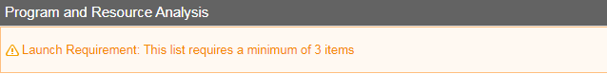

1. Please list the **number** of Full and Part Time faculty, staff and/ or managers/ administrator **positions** in this program over the past three years. Focus on your individual program.

|  |  |  |  |  |
| --- | --- | --- | --- | --- |
| **Academic Year** | **F = Faculty**  **S = Staff**  **M= Mgr/ Administrator** | **Full Time** | **Part time** | **Percentage Full to Part-time** (now auto-calculated. Faculty only) |
| Example:  1999 | F = 3  S = 15  M = 1 | F= 1  S = 12  M=1 | F=2  S = 3 | FT= 74%  PT= 26% |
| 2019-20 |  |  |  |  |
| 2018-19 |  |  |  |  |
| 2017-18 |  |  |  |  |

2. How have and will those with reassigned time, grant commitments and activity, projected retirements and sabbaticals affect personnel and load within the past in the next three years? What future impacts do you foresee?

## Evaluation of Resource Allocations

1. List the resource allocations from all sources (e.g., annual college budget request appropriations, Guided Pathways funds, grant funds, etc.) received in the last three years.  For annual college budget request appropriations, reference your previous three-year plan and annual updates.

Please evaluate the effectiveness of the resources utilized for your program.  How did these resources help student success and completion?   For college budget request appropriations, list the result of the evaluation strategy outlined in your previous three-year plan and annual updates.  For all other sources of funding, list the results of the evaluation strategy contained within the program or grant plan.

|  |  |  |  |  |
| --- | --- | --- | --- | --- |
| Resource Allocated | Funding Source | Academic Year | Purpose of Funding | Result |
| Ex:  $10,000 | Equity | 2017-18 | Purchase text for students in Math 5 | 83% of students turned homework in on time, an increase from 72% in 2016-17 |
|  |  |  |  |  |

## Departmental /Program Productivity Measurements

**1.** Determine the number of students you assist annually. Using the data provided by the business office, calculate your average cost effectiveness per student. **Counseling**: Student contacts should focus on number of counseling appointments per year. Please find your total contact hours in SARS.  **If you do not have student contact, please fill the academic year, total allocated budget and total spending cells.**

|  |  |  |  |  |
| --- | --- | --- | --- | --- |
| **1. Academic Year** | **2. Total Number of student contacts** | **3. Total allocated budget** | **4. Total spending** | **5. Total cost per student**  **(Student Contact/ Total Spending)** |
| Ex: 1999 | 715 | $15,000 | $14,500 | $20.28 per student |
| 2019-20 |  |  |  |  |
| 2018-19 |  |  |  |  |
| 2017-18 |  |  |  |  |

2. Evaluate your program costs. Are your costs in alignment with your budget? If not, what improvements can be made? Please explain any trends in spending, inconsistencies and unexpected results.

## Integrated Planning and Initiatives

1. What other areas (internal to the college) is your program partnering with (i.e. guided pathways, grant collaboration) in new ventures to improve student success at Gavilan College? What is the focus of this collaboration? What are the department and your Integrated Planning/ Guided Pathways partners’ plans for the next three years? **Consider addressing this in your Three-Year Program Plan.**

## Other Opportunities and Threats

1. Review for opportunities or threats to your program, or an analysis of important subgroups of the college population you serve. Examples may include environmental scans from the [Educational Master Plan](http://www.gavilan.edu/administration/budget/EducationMasterPlanFlipbook.php), changes in matriculation or articulation, student population, community and/ or labor market changes, etc. What are the departmental plans for the next three years? **Consider addressing this in your Three-Year Program Plan.**

## Additional Questions

Please consider providing answers to the following questions.  While these are optional, they provide crucial information about your equity efforts, training, classified professional support, and recruitment.

1. Does your division (or program) provide any training/mentoring for faculty and/ or classified professionals regarding professional development?

2. If there is a need for more faculty and/ or classified professional support in your area, please provide data to justify request. Is there a need for expanded support services (i.e. tutoring or math lab at the off-sites, in the evening, etc.) in your area?  Indicate how it would support the college mission and college goals for success and completion.

3. What, if anything, is your program doing to assist the District in attracting and retaining faculty and classified professionals who are sensitive to, and knowledgeable of, the needs of our continually changing constituencies, and reflect the make-up of our student body?

4. Are there program accomplishments/ milestones that have not been mentioned that you would like to highlight?

5. Please share any recommendations for improvements in the Program Integrated Plan and Review process, analysis, and questions.  Your comments will be helpful to the PIPR-RAP Committee and will become part of the permanent review record.

## 

## Example Three Year Program Plan

| Goal  One sentence limit. | Connection of Goal to Mission Statement, [Strategic Plan](http://www.gavilan.edu/administration/master_plan/docs/SP_GoalsStrategiesDraft-final.pdf) and SAO Results.  Use one sentence for each item. | Proposed Activity to Achieve Goal  One sentence limit. | Responsible Party  One sentence limit. | Fund amount requested.  If a collaboration, what % required from each partner?  If applicable, list each budget partner / source separately | Timeline to Completion  Month / Year | How Will You Evaluate Whether You Achieved Your Goal  Two sentence limit. |
| --- | --- | --- | --- | --- | --- | --- |
| Increase proportion of EOPS students completing degrees by five percentage points | Mission statement: works to prepare students from all backgrounds.  Strategic Plan:  Strategy 2, Goal 1  SAO Results:  Outcome 1; 76% of students completed 3 counseling visits | Increase counseling touch points from three times per semester to five times per semester by restructuring appointment and communication schedule | Dean, Special Programs | None | December 2021 | In three years, compare EOPS student graduation rates from before the touchpoint increase to graduation rates after the increase |
| Decrease average response time for IT requests from three days to two days | Mission statement:  Actively engages students  Strategic Plan:  Goal 2: Improve Efficiency  SAO Results:  Outcome 3: End-user problems will be responded to in a timely manner and resolved effectively by MIS staff. | Implement new workflow management software | Director of Information Technology | $7,500 for software package | September 2020 | Compare average response times from one year before software implementation to one year after implementation |

## 

## Executive Summary

1. Please provide a brief executive summary regarding program trends and highlights that surfaced in the writing of this report. Summarize, using narrative, your program goals for your next three years. Your audience will be your Peer Review Team, the PIPR-RAP Committee, Dean’s Council, ASGC, Academic Senate, President’s Council and Board of Trustees

# curriQunet

## Access and Log In

You can access curriQunet through the PIPR-RAP website or you can go directly to the site.

**1. Via PIPR-RAP webpage:**

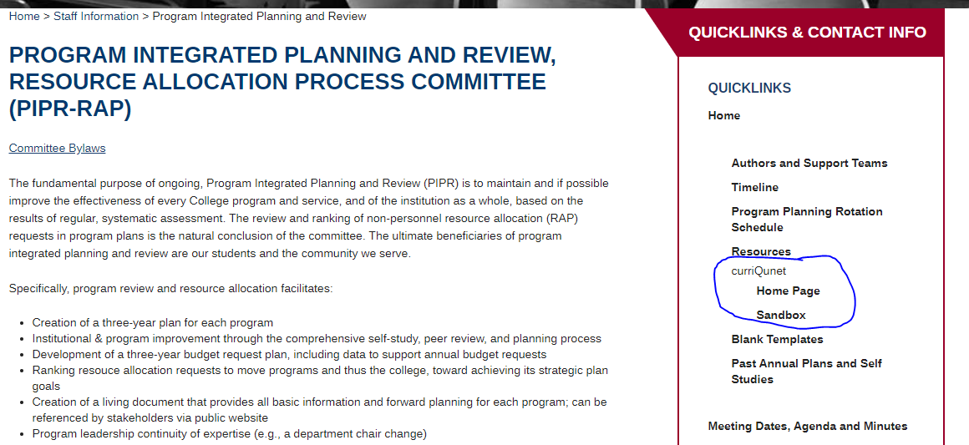

**OR**

**2. Directly through their address:**

Website: [gavilan.curricunet.com](https://gavilan.curricunet.com)

Enter your Email: [yourname@gavilan.edu](mailto:yourname@gavilan.edu)

Password: your password (will be ChangeMe44 until you change it)

Enter your email and password credentials as shown below, and then click the green “Login” button

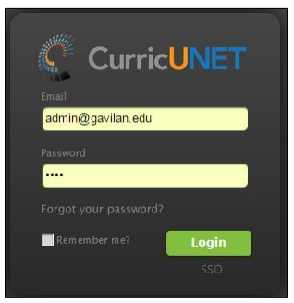

## 

## Creating your ‘Proposal’ (aka loading Program Review)

1. This is curriQunet’s home page. Press ‘Create Proposal’

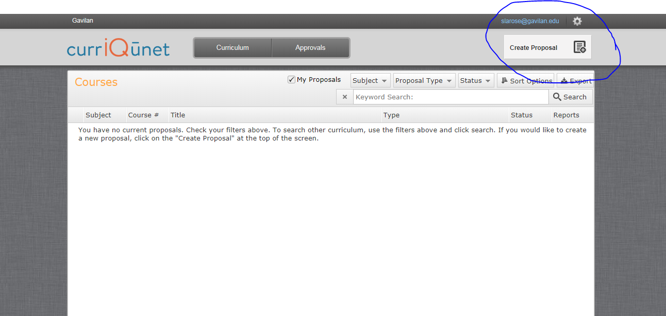

2. Select ‘Program Reviews’ from the drop down menu. Press Next

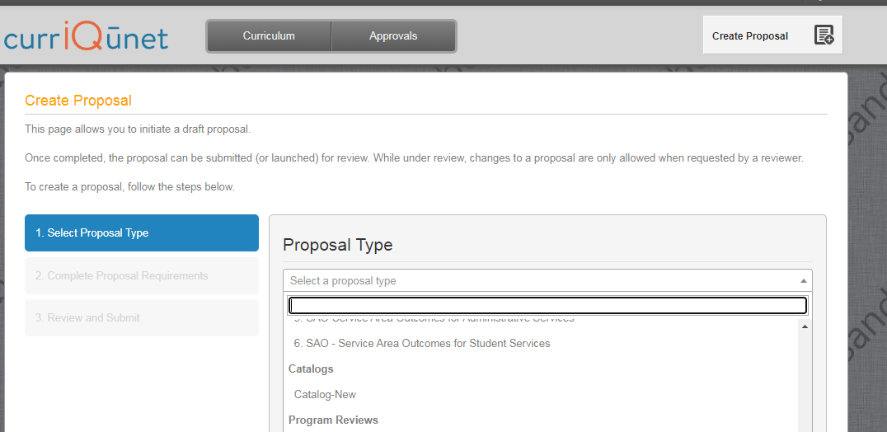

3. Select your program/ department/ area from the drop down menu. Your view might look slightly different. In the ‘Module Title’ cell, name your program review document. A suggested name might be your Program Name and Academic year, e.g. RPIE, 2020-21. Press ’Next’.

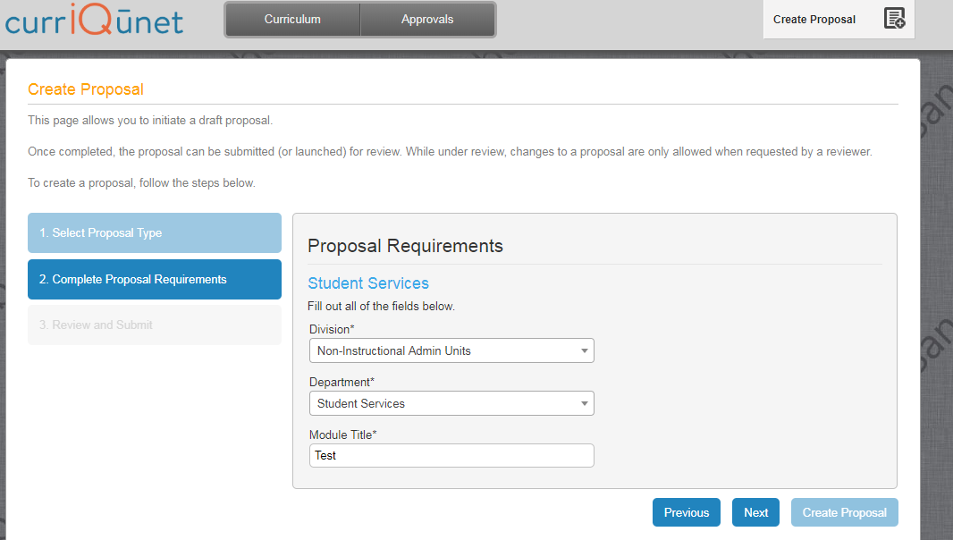

4. On the next screen press ‘Create Proposal’.

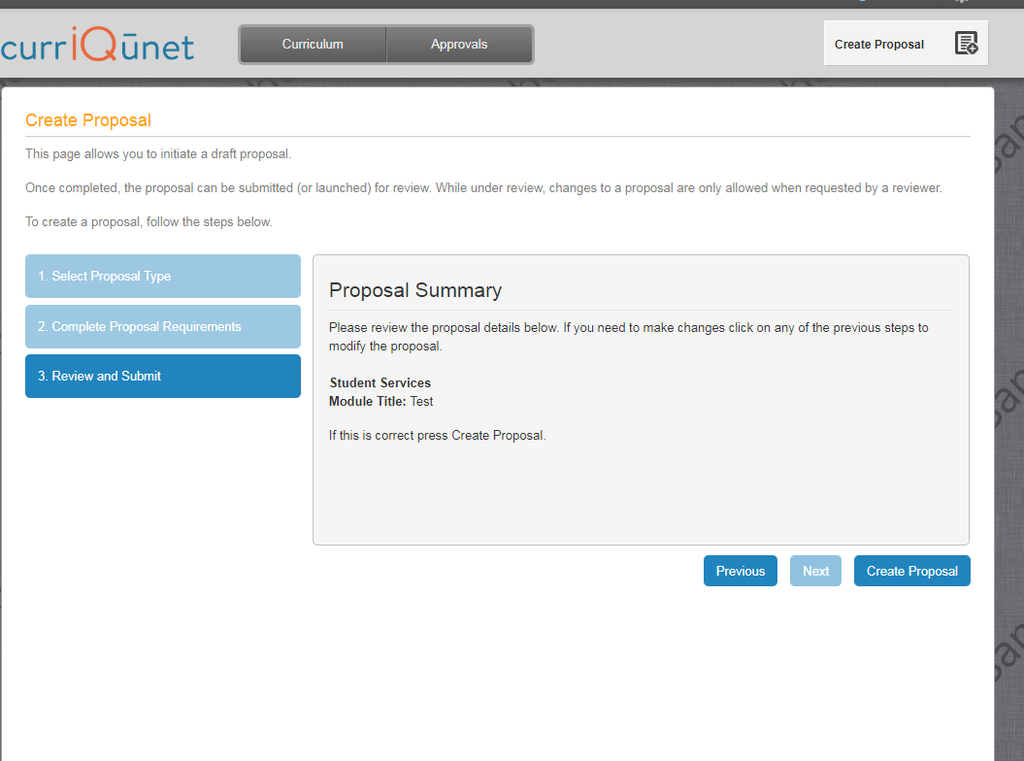

## 

## Program Review Cover

The Program Review Proposal opens to the “Cover” section. Any required field is marked with an *. Move between sections using the dark gray tabs to the far left. Sections with required fields also have an orange box showing your progress, which will turn green when you have completed all required fields. After completing all fields in the “Main” section, save any changes. Throughout the proposal you will only be prompted to save if changes are made. **Always remember to hit the save button or your work will be lost.**

On this main page, select the academic year from the drop-down menu. Enter your name in the originator cell. Press Save. You must manually select the section you would like to fill out next. Click on the text, not the box.

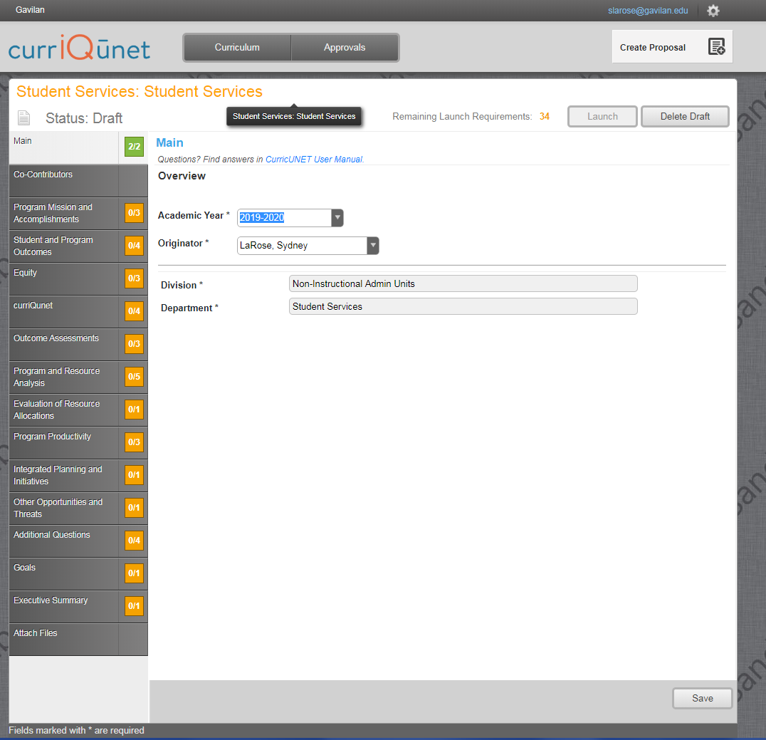

## 

## Co-Contributors

Co-contributors are those you are giving access to edit your document. This may include people in your department, your PIPR-RAP support team, etc. Select people from the list. If you don’t see someone listed, please contact [Sydney LaRose](mailto:slarose@gavilan.edu) and she will add them. Don’t forget to press ‘Save’ once done.

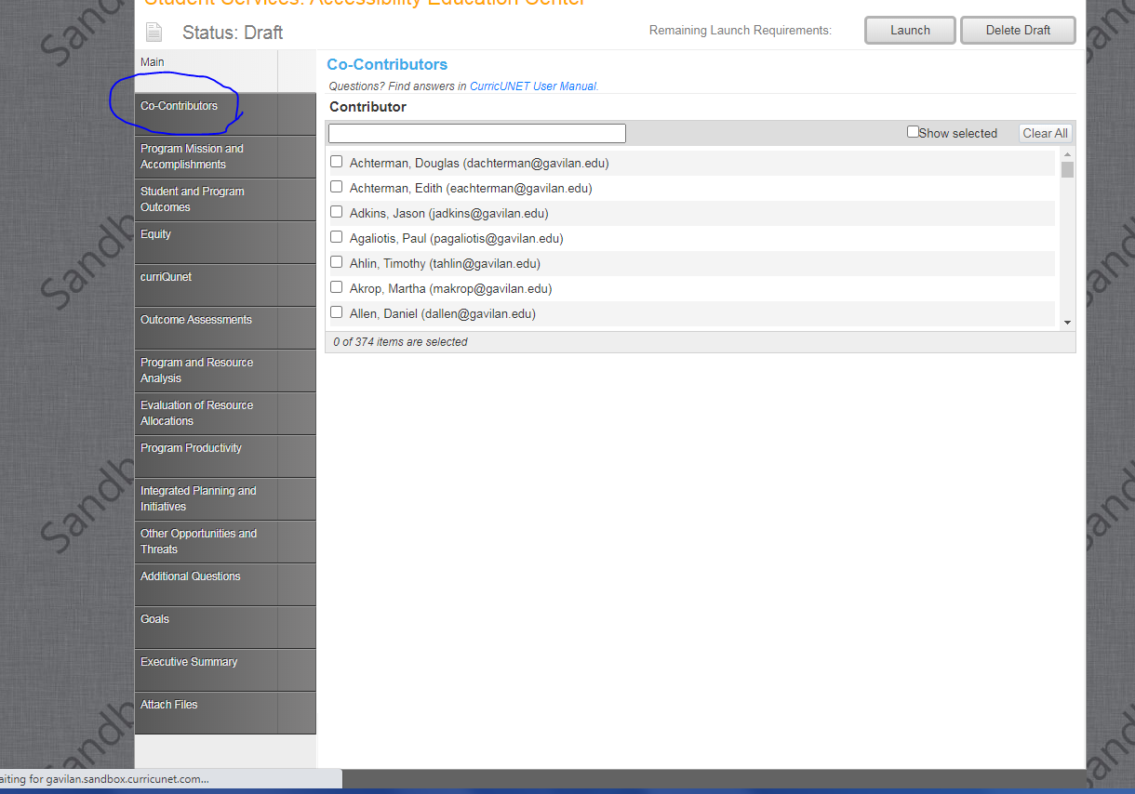

## Sections

From this point forward, you are completing sections of your Program Review. All questions require an answer in order to complete the section. If a question does not pertain to your program, N/A is an appropriate response. Each text section has a word limit of approximately 300 words (1,200 characters). Brief yet thorough statements are best.

## Launch Indicators

Launch indicators are your clue to what is required to complete each question.

* You will see indicators informing you ‘a value must be provided before launching’. That’s fancy speak for ‘Fill in this section’.
* Some questions are formatted in such a way that you will need to press an ‘add item’ button in order to load the question into the system.
* Add Item(s): Sometimes you will need to press the ‘add item’ button once to complete the question. Other times you are being asked a multi-year question and will need to “add an item”, fill in the information for one year, and repeat the process twice more to complete the answer for all years. Your Launch Requirement will inform you on what is needed.

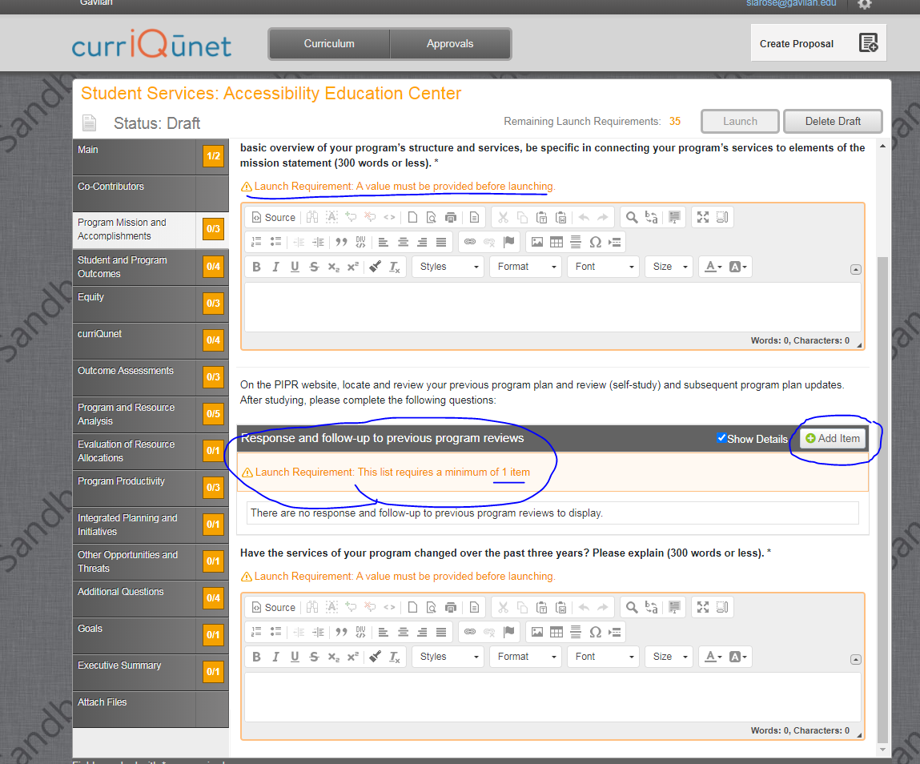

As always, if you have questions, contact your [support team](http://www.gavilan.edu/staff/program_planning/Author%20and%20Support%20Team%20Assignments.php) for assistance.