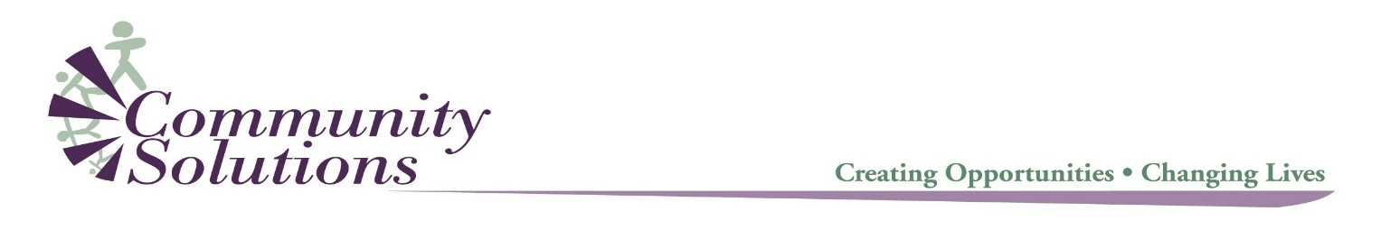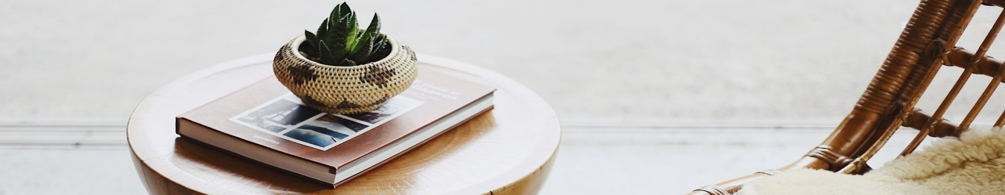

**Virtual Mindfulness Matters Sessions**

During this challenging time, we know that connection and mindfulness are so important to our physical and mental health. Join us for these 30- minute weekly sessions to connect, breathe and take care of ourselves.

**Mondays 9-9:30am**

*Guided Mindfulness hosted by Lisa Colliss*

Click here to join via Zoom at the scheduled time: [*https://zoom.us/j/107657241*](https://zoom.us/j/107657241)

**Wednesdays 12-12:30pm**

*Guided Mindfulness hosted by Lisa Colliss*

Click here to join via Zoom at the scheduled time: [*https://zoom.us/j/110188432*](https://zoom.us/j/110188432)

**Fridays 2-2:30pm**

*Mindful Movement hosted by Dora Shalts-Lastra*

Click here to join via Zoom at the scheduled time: [*https://zoom.us/j/948166911*](https://zoom.us/j/948166911)