

Retrieving your Gavilan Student Identification Number (Gavilan ID)

Recuperación de su número de identificación de estudiante de Gavilan

**取回你的**Gavilan**学生证号码。**

# **Computer│Computadora│**电脑



# Distance Education - Gavilan College**Phone│Teléfono│电话**

# **Computer│ Computadora│电脑**



|  |  |  |
| --- | --- | --- |
| Find the internet. Your computer will have one of these | Encuentra internet. Su computadora tendrá uno de estos. | 打开网络˳你的电脑会有以下网页之一˳ |



 Internet Explore Google Chrome Firefox

# **Phone│Teléfono│电话**

Find the internet│Spanish│Chinese



Android

iPhone

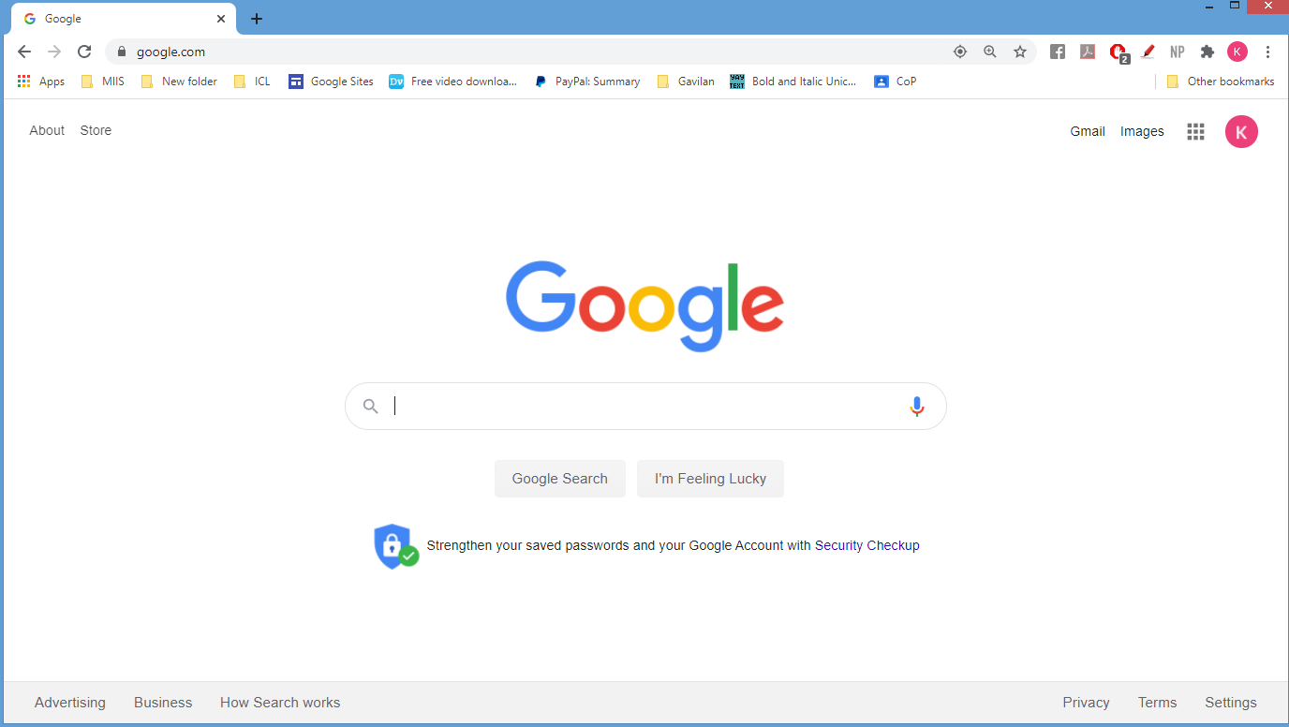



Type

[www.bkstr.com/gavilanstore](http://www.bkstr.com/gavilanstore)

Type│ Escribir│输入

my.gavilan.edu

Type

[www.bkstr.com/gavilanstore](http://www.bkstr.com/gavilanstore)

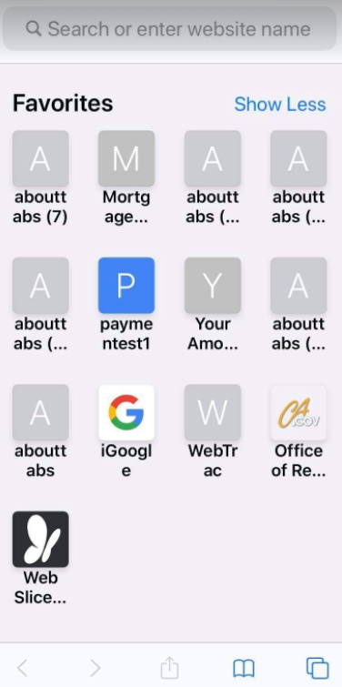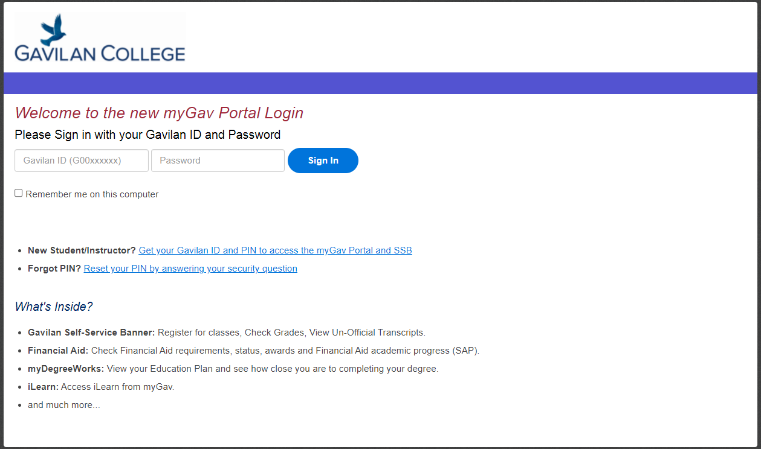



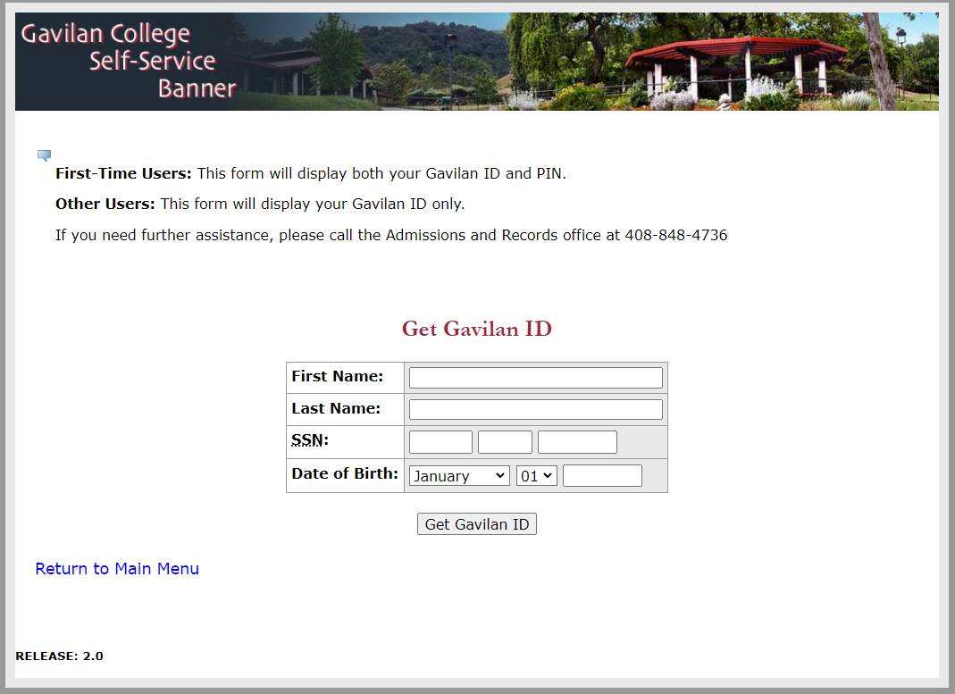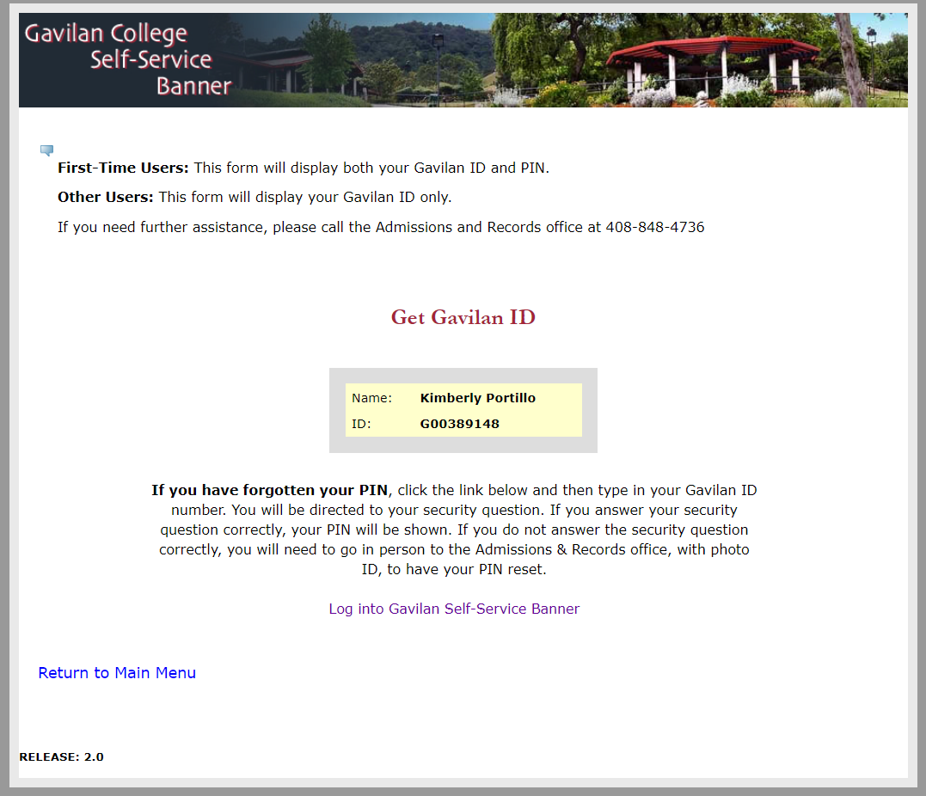

**Your Information**

**Tu information**

**您的信息**

**Your Information**

**Tu information**

**您的信息**

**For further assistance please call:**

**Para obtener más ayuda, llame al:**

**需要更多帮助请致电**

|  |  |
| --- | --- |
| **Ana Rocha:** | **408-852-2884** |
| **Victor De Reza:** | **408-250-5868** |
| **Admissions and Records Office:** | **408-848-4736** |