**Strategic Plan Development**

Timeline, Templates, Examples

Together our plans become progress.

A strategic plan is like a map. The process of developing the map is the process of considering all the directions the College could go, but in the end, the map conveys our decision of where we will go.

**Proposed Development Plan and Timeline**

By May 31, 2019, the Chancellor’s Office is requiring the completion of the submission of campus strategic goals that includes the signatures of the Board President, CEO, and Academic Senate President.

In order to create a comprehensive strategic plan, include college-wide input and have our strategic plan be approved by the board in May, the Strategic Planning (SP) Committee will need to take a leadership role in creating categories, facilitating group work that will generate input and potential goals, and finally condense these suggestions into our final strategic plan. College-wide participation will be possible (and necessary) due to the broad nature of each strategic category.

Due to time constraints, the Strategic Planning Committee will need to condense the Chancellor’s Office Vision for Success points down to four broad goal areas that will make up our Strategic Plan. The committee will need to do this work in order for future work to be contained and stay on point. Once the four goal areas are determined, the Strategic Planning Committee members will go to their constituency group(s) to inform and lead discussions that will generate strategies in each goal area.

Different needs and perspectives will present themselves based on the professional responsibilities of each group. Strong leadership by Strategic Planning Committee representatives during all planning exercises will be needed to keep teams on track and on point.

After facilitating information gathering strategies, the role of the Strategic Planning Committee will be to condense, combine, and simplify strategies into the four respective goal areas, evaluate the ideas, and select the most important strategies on which to focus to achieve each goal area. No more than three strategies are recommended for each goal area. Then, the Strategic Planning Committee will complete a planning grid (of the same format as PIPR) for each goal area.

Once College categories and goals are determined and finalized, each department will create two to three department-specific goals and activities in each strategic area, where applicable.

Necessary for Success:

Two Strategic Planning Committee Meetings in both February and March (total of four)

All Campus committees to allow SP members to have agenda time

Commitment from all SP members to facilitate information-gathering at meetings.

Below are:

Sample Timeline

Chancellor’s office Vision for Success points

Proposed worksheets for SP Committee

Proposed Departmental goals and plans document

Sample Strategic Plans from other colleges

**Proposed Timeline**

|  |  |  |
| --- | --- | --- |
| **Date** | **Action** | **Goals/ Homework** |
| February  Strategic Planning Committee first meeting | Review Chancellor’s Office Vision for Success.  Reduce Vision for Success into Four Broad categories.  Determine style and formatting of Strategic Plan | Review other college’s plans/ Best practices |
| February  Strategic Planning Committee  second meeting | Create categories Strategic Plan and sample goals | Get on committee agendas and conduct outreach for SP feedback |
| March  Strategic Planning Committee  first meeting | Combine feedback thus far |  |
| March  Strategic Planning Committee  second meeting | Finalize Strategic Plan with goals for board Information Packet |  |
| February/ March Shared Governance Meetings:  The Parade for Input | Feb 26: Leadership Council  March 4: Department Chairs (informational and  request to take back to departments)  Student Services Council  March 5: Academic Senate (informational and  request to take back to departments)  March 7: ASGC  Dean’s Council  ?????: Directors Confidentials Council  March 18: Department Chairs (return with input,  potential exercise within meeting)  Student Services Council  March 19: Academic Senate(return with input,  potential exercise within meeting)  March 20: CSEA Meeting  ????: Business and Support  Services  March 27: President’s Council (Review and  Approval) |  |
| Constituency groups approval timeline | March 5: Info Item Academic Senate  March 19: Academic Senate Approval  March 27: President’s Council  April 2: BoT Info Item Packet contents due  April 9: BoT Meeting; Info Item  May 7: BoT Approval Packet contents due  May 14: BoT Final Approval | |

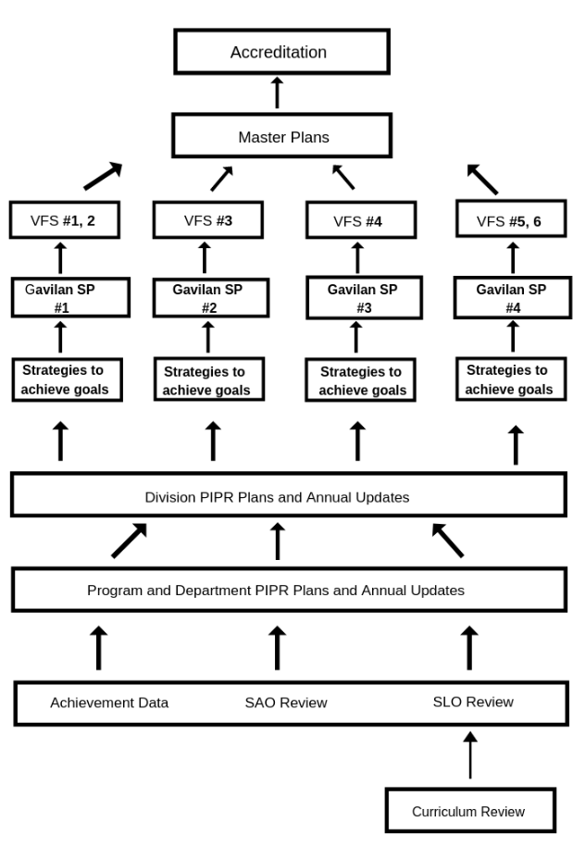

**Chancellor’s Office – Visions for Success**

|  |  |
| --- | --- |
| Vision for Success Goals | |
| 1.  Increase by at least 20% the number of CCC students annually who acquire associates degrees, credentials, certificates, or specific skill sets that prepare them for in-demand jobs.  Increase by 35% the number of CCC students transferring annually to a UC or a CSU. | 2.  Decrease the average number of units accumulated by CCC students earning associate’s degrees, from approximately 87 total units (the most recent system-wide average) to 79 total units—the average among the quintile of colleges showing the strongest performance on this measure. |
| 3.  Increase the percent of exiting CE students who report being employed in their field of study, from the most recent statewide average of 60 percent to an improved rate of 69 percent—the average among the quintile of colleges showing the strongest performance on this measure. | 4.  Reduce equity gaps across all of the above measures through faster improvements among traditionally underrepresented student groups, with the goal of cutting achievement gaps by 40 percent within 5 years and fully closing those achievement gaps within 10 years.  Reduce regional achievement gaps across all of the above measures through faster improvements among colleges located in regions with the lowest educational attainment of adults, with the ultimate goal of fully closing regional achievement gaps within 10 years. |

**Suggested Gavilan College**

**Strategic Plan Goals**

|  |  |
| --- | --- |
| Gavilan College Strategic Plan Goals | |
| 1. Increase Achievement  Within three years, increase the proportion of students completing transfer level English and Math within one year of matriculation from 7% to 14%. Within five years, increase to 25%.  Within three years, increase by 7% the proportion of students completing associates degrees from 554 to 582, completing credentials from X to X, completing certificates from 622 to 665, or specific skill sets that prepare them for in-demand jobs | 2. Improve Efficiency  Decrease the average number of units taken by graduates from 86 units to 83 units in three years, and to 77 units in five years. |
| 3. Improve Employment  Increase the proportion of CE graduates employed in their field of study from 72% to 75% over three years. | 4. Improve Equity  Improve equity outcomes by increasing course completion and graduation rates in target populations by five percentage points over three years. |

**Strategic Plan Goal #1 Worksheet**

|  |
| --- |
| Goal Area #1: Increase Achievement  Within three years, increase the proportion of students completing transfer level English and Math within one year of matriculation from 7% to 14%. Within five years, increase to 25%.  Within three years, increase by 7% the proportion of students completing associates degrees from 554 to 582, completing credentials from X to X, completing certificates from 622 to 665, or specific skill sets that prepare them for in-demand jobs |
| Strategies to Achieve Goal: |

**Strategic Plan Goal #2 Worksheet**

|  |
| --- |
| Goal Area #2: Improve Efficiency  Decrease the average number of units taken by graduates from 86 units to 83 units in three years, and to 77 units in five years. |
| Strategies to Achieve Goal: |

**Strategic Plan Goal #3 Worksheet**

|  |
| --- |
| Goal Area #3: Improve Employment  Increase the proportion of CE graduates employed in their field of study from 72% to 75% over three years. |
| Strategies to Achieve Goal: |

**Strategic Plan Goal #4 Worksheet**

|  |
| --- |
| Goal Area #4: Improve Equity  Improve equity outcomes by increasing course completion and graduation rates in target populations by five percentage points over three years. |
| Strategies to Achieve Goal: |

## Strategic PlanWorksheet

To add additional rows, click in the bottom cell on the right and push ’tab’ on the keyboard.

| Strategic Plan Goal | Strategy/Activity to Achieve Goal  One sentence limit | Responsible Party  One sentence limit | Resources required to complete strategy (personnel time, software /equipment, funds, etc.)  One sentence limit | Timeline to Completion  Month/ Year | How Will You Evaluate Whether The Strategy Achieved the Goal?  Two sentence limit |
| --- | --- | --- | --- | --- | --- |
|  |  |  |  |  |  |
|  |  |  |  |  |  |
|  |  |  |  |  |  |
|  |  |  |  |  |  |

**Strategic Planning Multiple Initiative Crosswalk**

|  | Strategic Plan Box #1 | Strategic Plan Box #2 | Strategic Plan Box #3 | Strategic Plan Box #4 |
| --- | --- | --- | --- | --- |
| **Vision for Success Goals** | Increase by at least 20% the number of CCC students annually who acquire associates degrees, credentials, certificates, or specific skill sets that prepare them for in-demand jobs.  Increase by 35% the number of CCC students transferring annually to a UC or a CSU. | Decrease the average number of units accumulated by CCC students earning associate’s degrees, from approximately 87 total units (the most recent system-wide average) to 79 total units—the average among the quintile of colleges showing the strongest performance on this measure. | Increase the percent of exiting CE students who report being employed in their field of study, from the most recent statewide average of 60 percent to an improved rate of 69 percent—the average among the quintile of colleges showing the strongest performance on this measure. | Reduce equity gaps across all of the above measures through faster improvements among traditionally underrepresented student groups, with the goal of cutting achievement gaps by 40% within 5 years and fully closing those gaps within 10 years.  Reduce regional achievement gaps across all of the above measures through faster improvements among colleges located in regions with the lowest educational attainment of adults, with the ultimate goal of fully closing regional achievement gaps within 10 years. |
| **Guided Pathways** | **Clarify:**  **______________**  **Get on Path:**   * K-12 partnerships   **______________**  **Stay on Path:**   * Ongoing, intrusive advising * Systems to identify at risk students   **Ensure Learning:**   * Inescapable student engagement * Systems for college and students to track mastery of learning outcomes that lead to credential, transfer or employment | **Clarify:**   * Course sequences, critical courses, embedded credentials and progress milestones * Core coursework aligned to each program of study   **______________**  **Get on Path:**   * Create a First year experience to explore field and choose major   **______________**  **Stay on Path**:   * Ongoing, intrusive advising * Redirect students who are not progressing in one program to a more viable path   **Ensure Learning:** | **Clarify:**  **______________**  **Get on Path:**   * K-12 partnerships   **_____________**  **Stay on Path:**    **Ensure Learning:**   * Applied learning experiences * Systems for college and students to track mastery of learning outcomes that lead to credential, transfer or employment | **Clarify:**  **______________**  **Get on Path:**   * Use MM for needs assessment * Contextualized, integrated academic support to help pass gateway courses   **______________**  **Stay on Path:**   * Ongoing, intrusive advising * Systems to identify at risk students     **Ensure Learning:**   * Systems for college and students to track mastery of learning outcomes that lead to credential, transfer or employment |
| **Board of Trustee Goals**  **2018** | Gain understanding of instructional matters (GP, Basic Skills Achievement, MM and other initiatives) that impact student success  Use integrative planning that manages college enrollment and exercises sound fiscal stewardship for the district. |  | Increase Community awareness and strategic partnerships through targeted marketing efforts, highlighting districts’ programs, growths, and connection to community agencies and industry | Gain understanding of instructional matters (GP, Basic Skills Achievement, MM and other initiatives) that impact student success |
| **Student Centered Funding Formula** | Measure FTES enrollments calculated on a three year average  Success incentive to reward for successful outcomes of blended equity student success/ performance in :   * Completion of AS, ADT,9 CE units, Certificate completion of at least 18 units * Transfer to a 4-year institution | Success incentive to reward for successful outcomes of blended equity student success/ performance in :   * Progression (English and Math transfer level completion | Success incentive to reward for successful outcomes of blended equity student success/ performance in :   * Attain living wage after 1-yr post completion | Supplemental grants based on Pell Grant , College Promise and AB 540 headcounts and success of Pell Grant students  Non-credit and CDCP to be funded at current rate (non-SCFF) |

**Strategic Plan**

**Samples**

|  |  |
| --- | --- |
| **1. Strengthen the FOUNDATION**   * Resource Development   + Ensure fiscal and financial strength   + Develop governance mechanisms and structures   + Reconstructed Web Site   + Employee Development | 2. **Strengthen STUDENT POTENTIAL**   * Admissions and Enrollment   + Destination of choice   + Establish affordable tuition   + Offer financial assistance that supports improvement of retention and graduation rates   + Expand recruitment marketing plans and benchmark study   + Make opportunity affordable |
| 3. **Strengthen CAREER OPPORTUNITIES**   * Career Development   + Prepare students to launch and advance in professionally enviable and personally satisfying careers.   + Students will be aggressively sought after in the workplace   + Transform career development services   + Re-engineer experiential education   + Student career progression: Placement, compensation and satisfaction | 4. **Strengthen the EXPERIENCE**   * Academic and Student Life   + Create exciting learning communities offering programs that are distinguished by their relevance, excellence and rigor as well as the high level of instruction * Strengthen Advising   + Dedicated counselors * Distance Education   + Educate faculty on OEI   + Teach the teacher   + DE best practices * Retention, retention, retention   + Exceed the goal   + First Year Experience   + Related cohort model |

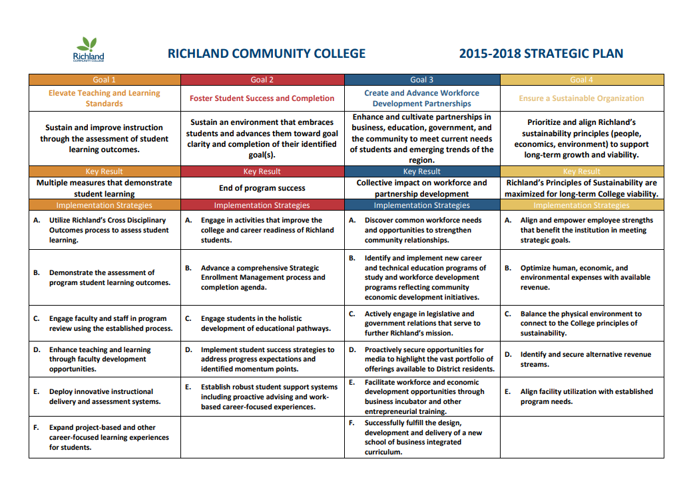

**Mesa Community College Strategic Priorities**

|  |  |
| --- | --- |
| 1. Strategic Enrollment Management: Supporting student success from recruitment to completion   * Enrollment Priority 1: SEM Plan will support the Academic Master Plan (AMP). * Enrollment Priority 2: Outreach, recruitment and marketing efforts support college enrollment and FTSE goals. * Enrollment Priority 3: Meet or exceed college enrollment and FTSE goals by increasing student success, retention, persistence and completion. * Enrollment Priority 4: Increase student satisfaction and engagement across all support services and academic affairs to meet or exceed comparable national cohort scores. | 2. Effective Teaching and Learning: Crafting environments and experiences that foster the development of knowledge and abilities.  MCC will focus on understanding how our students learn and craft environments and experiences that foster the development of knowledge and abilities Students will experience the best of emerging teaching and learning experiences, which are often linked to technologies. Students will have access to creative and innovative program structures and modalities well-suited for these learning environments.   * Strategic Priority Guiding Statement Part 1: MCC will focus on understanding how our students learn and will craft learning environments (physical and virtual) and experiences that foster the development of knowledge, attitudes, and abilities, particularly for MCC’s 4Cs Student Learning Outcomes. * Strategic Priority Guiding Statement Part 2: Students will experience the best of emerging teaching and learning experiences, as determined through informed improvement and scholarship of teaching and learning efforts, which are often linked to technologies. * Strategic Priority Guiding Statement Part 3: Students will have access to creative and innovative program structures and modalities (i.e. short-term, hybrid, competency-based) well-suited for these learning environments. |
| 3. Signature Career Pathways: Providing evolving, in-demand programs designed for student success  The Strategic Planning Committee is currently working with college constituents to fully develop this Strategic Priority. The following serves as a guiding statement for the development of this Strategic Priority: MCC will provide up-to-date, in-demand programs that are highly attractive to potential students by conducting a comprehensive review of current program offerings in light of occupational forecasts related to sectors of job growth with the goal of developing evolving, in-demand programs designed for student success. | |