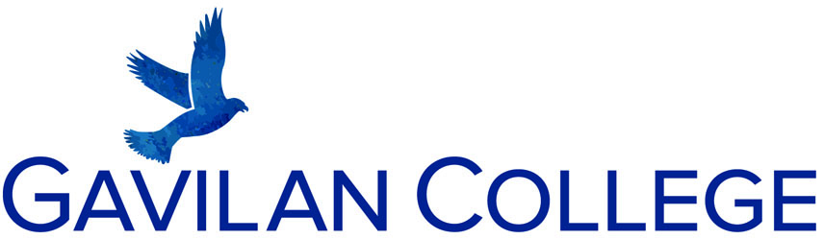

Web Accessibility Complaint and Resolution Process
Gavilan College is committed to making its online applications accessible to individuals of all abilities. To that end, Gavilan College seeks to develop websites and web applications to be in compliance with California Government Code 7405, that specifies conformance with the standards set forth in Section 508 of the Rehabilitation Act of 1973.

Complaint Investigation and Resolution Process
If an individual with a disability encounters an issue with a website or web application developed or owned by Gavilan College that individual may report the barrier via phone, email, or to the listed mailing address. Once a report is made, the following steps are taken:

- Phone messages and physical mail identifying an accessibility issue with a Gavilan College developed or owned website or web application will be submitted to the Web Developer (408-846-4908) or High Tech Center (408-848-4823) or TTY (408-846-4924).

- Email messages sent to the accessibility@gavilan.edu will be directed to Web Developer and the High Tech Center.

- Upon receipt of an accessibility complaint or barrier reporting, the Web Developer will:
- Create a ticket for the specific product and accessibility issue reported, including date received;
- Investigate the issue and provide a preliminary response to the reporting individual within 48 business hours of receiving the complaint.
- If an accessibility issue is discovered within the context of the supported assistive technologies and Information and Communication Technology applications at the college, the Web Developer will, in consultation with the appropriate staff:
- Define the existing accessibility issue within the ticket and acceptance criteria necessary to resolve the issue;
- Specify the level of priority for resolving the accessibility issue and identify a timeline for resolution.

- Following the creation of the accessibility ticket, the Web Developer will respond to the reporting individual, if appropriate, and inform the individual as to the timeline for resolution.

- The Web Developer will communicate with the reporting individual to determine if an alternate access solution is necessary while the accessibility issue is resolved.

- Following the resolution and/or conclusion of the accessibility issue, the Web Developer will identify in the ticket the date at which the accessibility issue was completed.

If a satisfactory result cannot be provided and you want to file an official grievance in the area of civil rights for persons with disabilities (ADA/Section 504/508), please contact the Equal Opportunity Officer, Eric Ramones, HR103, eramones@gavilan.edu, and 408-848-4753.

