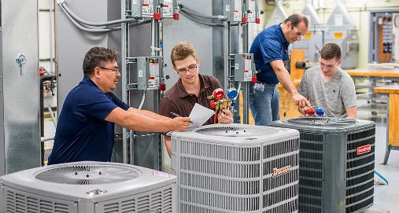

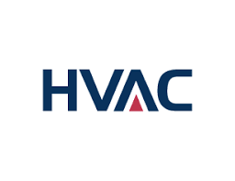

Heating, Ventilation, and Air Conditioning  
**Associate in Science or Certificate of Achievement**

**HVAC Wages**

The median wage in 2022 for Heating/Air Conditioning and Refrigeration Workers in California is $61,738 annually, or $29.69 hourly.

**Program Description**

This degree is designed to prepare students to enter the Heating, Air Conditioning, and Refrigeration Technology field. Students receiving the certificate will have the knowledge and skills essential for employment in a variety of careers, including AC Technicians, Heating Technicians, Refrigeration Technicians, HVAC Mechanics, and HVAC Installers.

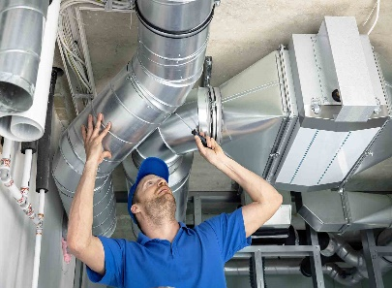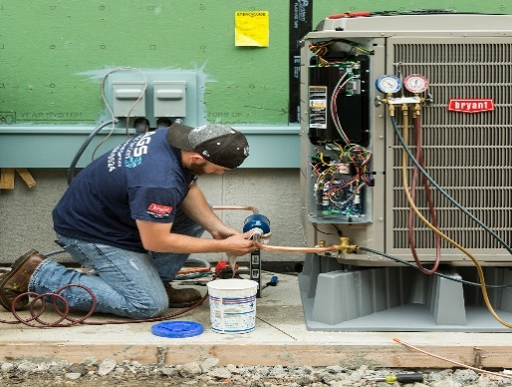

**www.gavilan.edu/CareerEd**

Jessica Weiler

Career Education Counselor

[jweiler@gavilan.edu](mailto:jweiler@gavilan.edu)



### Program Requirements (24 UNITS)

HVAC 201 Basic Electrical Theory . . . . . . . . . . . . 4 units  
HVAC 202 Basic Refrigeration . . . . . . . . . . . . . . . 4 units  
HVAC 203 Heating Systems . . . . . . . . . . . . . . . . .4 units  
HVAC 204 Air-Conditioning and Heat Pumps . . . .4 units  
HVAC 205 Commercial Refrig. and Ice Machines 4 units  
HVAC 206 HVAC Controls . . . . . . . . . . . . . . . . . . 4 units

**HVAC Job Outlook**

As the population and number of buildings increase, so does the demand for residential, commercial, and industrial climate-control systems. The complexity of today’s climate control systems increases the possibility that equipment may malfunction, creating more employment opportunities for Technicians.