Internal vs External

We are running into a small problem on a lot of the pages lately. Folks are marking links as ‘external’ when they are really ‘internal’. For example
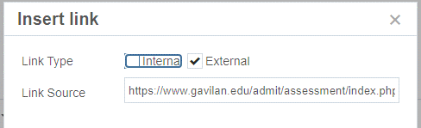

Anything that at www.gavilan.edu is internal and why that is important is if someone decides to delete ‘assesmenent/index.php’ or change its name, the CMS is smart enough to change to the new name over the entire site or at least warn a person not to delete it because there are links to it.

For example: A person changed the name of her page from ‘Important%20Dates%20and%20Cultural%20Events.php’ to ‘ImportantDatesAndCulturalEvents.php’. This broke the link on the Counseling home page because the link was marked as external.
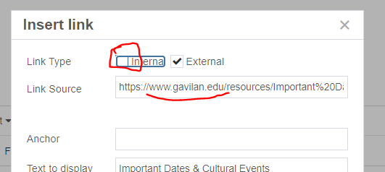

If the link was marked as Internal, which means the page belongs to us on Gavilan.edu, the CMS would have fixed it automatically. That is the advantage of marking links Internal.

