Edit Home Page Sliders

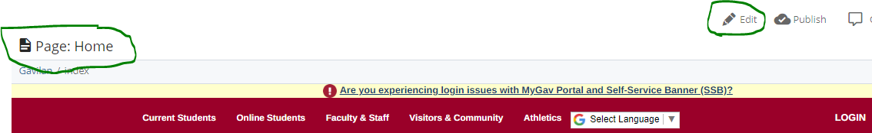
Go to the homepage on the CMS at https://cms.gavilan.edu, click edit.
These are the slides, you can delete, re-arrange, and add up to a maximum of five.


Example: Welcome Center Slide on the homepage
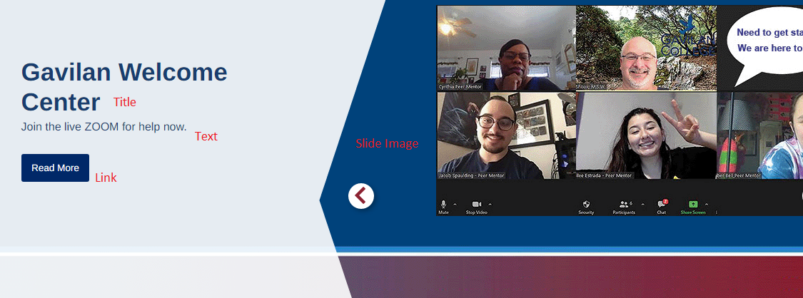
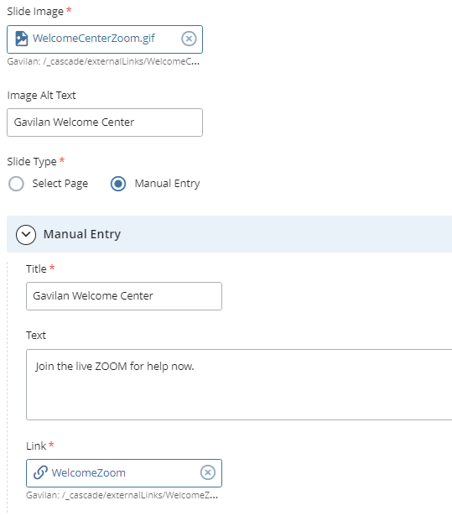
Click on the slide and fill out the fields below in the CMS.

Image Size is important or else images will distort. The image must be 1,200 by 560 pixels.

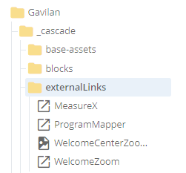
Link: The link can be any page at www.gavilan.edu but if it is an outside like, like in this case a Zoom link, you must manually create the link by going to _cascad/exteranalLinks.
Right click on ‘externalLinks’ to select it and make it blue.

Click Add Content

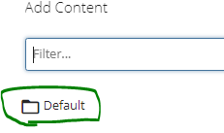
Click Default

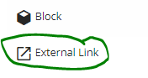
Click External Link

Fill in the blanks
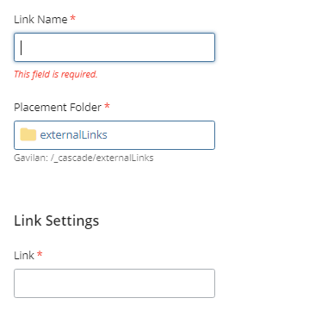

Click the three dots and Submit
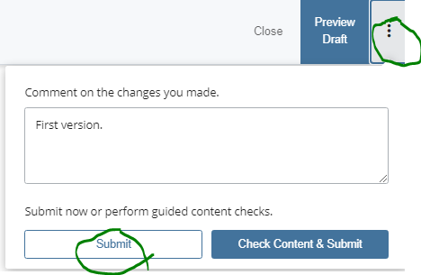

Now that the link is created, chose that link in this field.
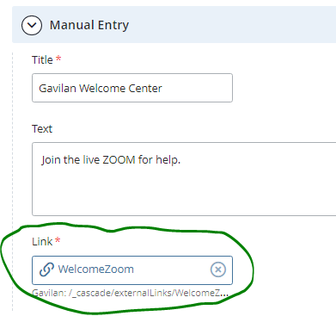

If the link is a www.gavilan.edu link, click inside the link box and browse to the page you want to connect to.


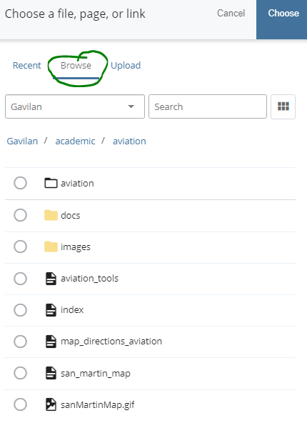

When finished
Click submit and publish. Submit saves the changes to the database and publish moves the page to the web server. If you do not publish your page, the changes will never appear on the web site.
